ELEX 7890 Capstone Project

**Final Report**

**Personal Electromagnetic Field Monitor**

Abstract

Health problems caused by electromagnetic fields (EMF) is a concern that warranted studies from international organizations, such as the Institute of Electrical and Electronic Engineers (IEEE). They published several guidelines outlining how much EMF exposure will potentially cause health issues for humans. This is quite important to BC Hydro, since they are building permanent facilities beneath high voltage power lines, which is a source of low frequency EMF radiation. Although classical calculations have shown that the worst-case scenario of EMF exposure is not high enough to be of consequence, having measured data to back up that conclusion would help ensure employee safety. As a result, BC Hydro sponsored this capstone project, where our team was tasked with developing a device to measure and display the electric and magnetic field strengths, then store it in a database.

|  |  |
| --- | --- |
| **Submitted as part of a BCIT electrical engineering Capstone project: 2019-2020** | |
| Prepared by: | Submission Date: |
| Nicholas Huttemann | 2020-04-30 |
| Joseph Dobrzanski |  |
| Bhavik Maisuria |  |

Table of Contents

Executive Summary 5

Acknowledgements 6

1 Introduction 7

2 Background and Motivation 8

2.1 End-Users and Stakeholders 8

2.2 Application and Need 8

2.3 State of the Art 9

2.3.1 BC Hydro Practices and Regulations 9

2.3.1.1 General MCF Regulations and Procedures 9

2.3.1.2 EMF Analysis 10

2.3.2 Current Technologies 11

2.3.2.1 Magnetometers and Similar Devices 11

2.3.2.2 LPWAN IoT 12

2.4 Key Literature Summary 13

3 Scope of Work 14

3.1 Longer-Term Objectives 14

3.1 Capstone Project Objectives 15

3.3 Project Execution and Accomplishments 15

3.4 Collaboration and External Input to Project 16

3.4.1 BBA Program Review and Consultation 17

3.4.2 External Review and Consultation - Design 17

3.4.3 External Review and Consultation - IoT 18

3.4.4 BC Hydro 18

4 Project Implementation 18

4.1 High-Level Description 18

4.1.1 Microcontroller 20

4.1.2 Magnetometer Sensor 20

4.1.3 User Input 21

4.1.4 System Output 21

4.1.5 IoT Module 22

4.1.6 Internal Storage 23

4.1.7 Database and Data Transfer 23

4.1.8 Battery and Charging 24

4.2 Design and Implementation 25

4.2.1 Initial Prototype 25

4.2.1.1 RTOS and Development Environment 26

4.2.1.2 60 Hz EMF Measurement 27

4.2.1.3 Azure IoT Central 29

4.2.1.4 Battery 30

4.2.1.5 User interface 31

4.2.2 Optimized Prototype 35

4.2.2.1 Internal Storage 36

4.2.2.2 PCB Design 37

4.2.2.3 Enclosure 40

4.2.2.4 User Interface 40

4.2.3 Summary of Costs 42

4.3 Results, Testing, and Verification 42

4.3.1 EMF Measurement 43

4.3.1.1 60 Hz EMF Sensing 43

4.3.1.2 Data processing 46

4.3.1.3 Calibration 47

4.3.2 Battery 47

4.3.2.1 Charging and Discharging 47

4.3.2.2 Powering the NUCLEO off the Battery Babysitter 48

4.3.2.3 Monitoring the State of the Battery 48

4.3.3 User interface 49

4.3.3.1 Measure button input, with debouncing 49

4.3.3.2 Ensure screen for initial prototype works with microcontroller 49

4.3.3.3 Ensure LittleVGL can display dynamic values and respond to user input 50

4.3.3.4 Use LittleVGL to make menu system and display EMF information 51

4.3.3.5 Ensure screen for optimized prototype works with microcontroller 52

5 Conclusions and Recommendations for Future Work 52

References 54

Appendix A: Magnetometer Sensor Thread Flowchart 56

Appendix B: Table of Orders 57

Table of Figures

Figure 1: Magnetic field profile when 2L4 only is in service 10

Figure 2: Magnetic field profile for double circuits with one line active for each 11

Figure 3: NB-IoT vs LTE-M 13

Figure 4: Sub-system breakdown of EMF Monitor 19

Figure 5: MMC5603NJ breakout board 21

Figure 6: Quectel BG96 modem board 22

Figure 7: Sparkfun MicroSD breakout board 23

Figure 8: Monitors connected to a cloud-based database 23

Figure 9: Sparkfun Battery Babysitter 24

Figure 10: Telus IoT kit for initial prototype 25

Figure 11: Mbed board architecture 26

Figure 12: FIR filter frequency response 27

Figure 13: FIR Filter Block Diagram 28

Figure 14: Azure IoT Central app mockup 29

Figure 15: EMF Monitor main screen display 32

Figure 16: Settings menu one (left) and two (right) for EMF Monitor 34

Figure 17: BG96 board modifications 36

Figure 18: Python transfer app waiting 37

Figure 19: Python transfer app main window 37

Figure 20: Schematic of custom PCB for optimized prototype 38

Figure 21: Copper traces for PCB design for optimized prototype 39

Figure 22: Render of PCB for optimized prototype 39

Figure 23: Button tentatively chosen for optimized prototype 41

Figure 24: LCD screen when displaying text 41

Figure 25: Solder bridge made across J3 (near top-right corner of the PCB) to enable SPI mode 42

Figure 26: Initial prototype 43

Figure 27: LSM303AGR FFT 44

Figure 28: MMC5603NJ FFT 45

Figure 29: MMC5603NJ increased sample rate serial Output 45

Figure 30: MMC5603NJ filtered FFT 46

Figure 31: MMC5603NJ filtered and unfiltered EMF data 46

Figure 32: Blue LED indicating charge status and red LED indicating output status 47

Figure 33: Headers for choosing input power source 48

Figure 34: COM port showing battery percentage sent via I2C 48

Figure 35: Testing to see if the screen driver works using shapes (left) and strings (right) 50

Figure 36: Screen linking input and output through GUI library. 51

Figure 37: Magnetometer sensor thread flowchart 56

Table of Tables

Table 1: Mbed Threads Ordered by Descending Priority 20

Table 2: LSM303AGR vs MMC5603NJ 28

Table 3: Battery capacity requirements for 8-hour shift 30

Table 4: Standard commands for BQ27441 31

Table 5: Comparison of bytes send using pixel-by-pixel updates vs. rectangle area updates 51

Table 6: Table of capstone expenditures 57

# Executive Summary

BC Hydro is installing permanent sorting work area facilities underneath high voltage power lines at their Material Classification Facility, which exposes employees to low frequency electromagnetic fields (EMF). Although calculations have shown the EMF intensity to be within acceptable levels, verifying this with measurements will help ensure employee safety. As a result, BC Hydro sponsored this project to develop a wearable, pocket-sized device for workers at their facilities. The EMF Monitor is to record and display EMF data during a work-shift, then store it in a database. Our team decided to use the Cloud-based service, Microsoft Azure, as the database in order to learn more about the Internet of Things (IoT) technologies and to differentiate our device from similar products on the market, such as Gaussmeters (which, from our research, did not meet all the BC Hydro’s design requirements, likely due to this being a more niche market).

The plan for this project was to develop an initial prototype and an optimized prototype. The initial prototype would use an IoT kit to develop core design features for the device. The optimized prototype is where we create a field-testable product. Key features are refined, new features are added, and a custom PCB is designed/created to help minimize the space needed for the circuitry. As this project involved many areas outside the experience of the team, we consulted with groups with that expertise. Our team consulted with Bachelor of Business Administration students to look at the business applications of the device, BCIT’s Make+ group to advise us on mechanical aspects of the project (e.g. how to waterproof an enclosure), Jony Bassan (also from the Make+ team) to inform us on how to more effectively use the IoT kit we purchased, and BC Hydro to clarify design details of the project.

The initial prototype we developed using the IoT kit contained the essentials of the project. A magnetometer was used to measure the EMF intensity, the microcontroller applied a filter to the data to isolate the desired EMF frequency’s strength, and that information was then displayed on a screen. Other modules, (such as measuring the battery voltage, and displaying a menu system) progressed as well but were still incomplete and/or unintegrated. Part of the delay in development came from unexpected difficulties, such as the software development environment used for our kit not having a debugger (to help troubleshoot programming errors) or Microsoft Azure as a database not having a convenient way of separating which data came from which device.

Adjusting for this in the optimized prototype, an internal memory package was added with the intention of later creating a program to download the stored EMF data from a desktop via USB cable. Due to the COVID-19 situation causing capstone to end early, the optimized prototype did not fully come together. Although many of the modules were approaching completion (e.g. most items in the menu responds to user input in GUI module, the battery-management module could measure the battery’s voltage, etc.), integration of them together did not happen. Additionally, the shipping of the PCB we designed was delayed and did not arrive in time.

Overall, the capstone project was behind schedule as a result of the previously mentioned issues and was unable to recover due to COVID-19. Although this resulted in the project ending with an incomplete optimized prototype and not all design requirements being met, this capstone proved to be a good learning experience in working with IoT systems and in handling what all engineering projects have: unexpected challenges.

# Acknowledgements

We would like to thank Bob Stewart and William Fajber from BC Hydro, who came up with the concept for this project, provided us background information on the facility conditions, and gave guidance on design questions we had throughout the school year.

We would also like to thank Reza Vahidnia, our BCIT capstone mentor. He always encouraged us during our weekly meetings, answered the questions we had, and contacted other BCIT staff to try answering the questions he could not. Moreover, he helped us determine whether BCIT has certain equipment useful to our project (e.g. a high quality Gaussmeter) or helped us order the equipment we needed.

# 1 Introduction

The purpose of this report is to meet one of the requirements of the Bachelor of Electrical Engineering (B.Eng) capstone program and to describe our team’s project, the Personal EMF Monitor. It is intended for those in the BCIT Electrical Engineering department who will be evaluating our capstone project, and for those working with us from our sponsor, BC Hydro. Information from this report can be understood more thoroughly by those with a background in engineering, technology, or physics. However, individuals not from one of those backgrounds can still follow most of the report, though certain technical jargon, concepts, engineering tools, etc. may need to be looked up for a more comprehensive understanding.

Due to concerns over the spread of the COVID-19 virus, our capstone was stopped prematurely on March 17, 2020. The required labs at BCIT’s Burnaby campus were closed, which meant that not all group members had access to electronics equipment needed to work on/debug the project (i.e. not all members had a soldering iron, hot air gun, oscilloscope, 3D printer, etc. which may assist in completing certain modules of the project). Although progress on the software for a module can be done from home in isolation, integrating different modules together became impossible, bringing the project to a halt.

The main sections of the report following this introduction are the background/motivation, scope of work, project implementation, and conclusions/recommendations for future work:

* **Background and Motivation**: This section describes the motivation behind this project, the need of our product, and the people that will be using it. Moreover, scientific literature about EMF exposure and the current state of technology related to the core concepts of this device will be explored to provide adequate background information on our project.
* **Scope of Work**: Here, the objectives (both ideal and realistic) are outlined, and to what degree those objectives were accomplished. Moreover, which groups our team collaborated/consulted with are discussed.
* **Project Implementation**: This is where the EMF Monitor itself is described, both on a high-level and in the finer details. Additionally, the design considerations, the implementation/results, and the testing that went into verifying the design requirements are explored.
* **Conclusions/Recommendations for Future Work**: This section wraps up the report by summarizing the results of the project and recommending what sort of follow-up and future work should be done.

This covers the main points from our capstone proposal [1], with additional sections describing the work done since then. Thus, most of the report covers what was done for capstone from January 6, 2020 to March 17, 2020. Moreover, generally only the more significant or closely related details to this project are included. For example, when discussing the background information of how the device works, the report may mention the why a certain type of filter is used for a given application, but the detailed theory behind why that filter is able to do what does is considered out of scope and therefore not included.

# 2 Background and Motivation

The purpose of our project is to design a device that would allow BC Hydro employees to view their 60 Hz EMF exposure while working under high voltage power lines, allowing them to see if their exposure reaches dangerous levels. 60 Hz is to be isolated from the spectrum, due to it being the frequency the power lines are operated at. This section describes the end-users/stakeholders and the application/need of our device in more detail.

## 2.1 End-Users and Stakeholders

In order to address the concerns raised about employee EMF over-exposure due to high voltage power lines, BC Hydro has enlisted several BCIT students to develop a device to monitor EMF levels. Technical documents on facility system parameters, voltage induction, EMF levels, and other requested information was provided by the company’s project liaison, Bob Stewart (P. Eng.). Moreover, BC Hydro, as the project sponsor, ultimately holds ownership of the deliverables made for this capstone. The students involved in the project are the 4th year electrical engineering students Nicholas Huttemann, Bhavik Maisuria, and Joseph Dobrzanski. To guide this project and provide other support, one of BCIT’s Electrical Engineering instructors, Reza Vahidnia (PhD), is acting as this capstone’s mentor.

To ensure the successful completion of this capstone, various aspects of this project are delegated to different team members. During the initial prototyping phase of this project, Nick was primarily responsible for developing the EMF measurement and IoT aspects of the project (communicating with the magnetometer, signal processing, sending data wirelessly to Microsoft Azure, setting up the database, etc.). Bhavik worked on the hardware design portions of the monitor and miscellaneous microcontroller tasks (communicating with the internal battery charger board, designing the PCB for the optimized prototype, etc.). Finally, Joseph worked on the user interface and supported the other team members in various parts of their duties (displaying information on a screen, allowing users to configure the monitor, researching/selecting parts required for the monitor, etc.). The part developed by an individual was tested by that individual, while integration of different modules involved all members who created the modules being integrated with each other. Moreover, decisions on final parts being chosen or a particular design (e.g. for the PCB) are verified by the other team members before being carried out. This division of work carried on throughout the term until the end of capstone.

## 2.2 Application and Need

BC Hydro is a company that prioritizes staff safety. Since their work areas under high voltage transmission lines are exposed to higher levels of EMF than normal, questions about employee safety from EMF exposure were raised. These concerns are not without basis, since there are documents provided by various organizations, such as the World Health Organization, on EMF exposure levels [2]. However, although the EMF exposure at 60 Hz (which is the frequency the power lines are operated at) is expected to be within a safe amount, the crux of the matter is that it is not known for certain what kind of EMF strength is present. Consequently, our project can help demystify this issue and provide another tool in securing employee safety.

BC Hydro employees, as the prospective users, will carry this device on their person (e.g. in a coat pocket or on their belt) while they work under high voltage power lines. They are assumed to be working outdoors, with standard full-time work shifts (7.5 hours per day). Additionally, BC Hydro requires that our system be able to support up to 20 employees in the MCF. However, as BC Hydro builds more facilities with similar working conditions, additional EMF Monitors may be required for the staff who would work there. Expanding the database to accommodate the additional device’s data is a trivial task. Overall, although this product may not have a large prospective customer base due to its niche application, it can still find use for any(e.g. BC Hydro or any other related utility/power company) workers expected to work near high voltage transmission lines.

Although this device is not strictly necessary due to the expected EMF levels being sufficiently low (and with BC Hydro monitoring the voltage and current of their transmission lines), it provides assurance that EMF levels are what they are expected to be. Moreover, being able to track the EMF levels over a given timeframe allows supervisors to track EMF trends (e.g. what is the monthly exposure, does the EMF fluctuate over time, etc.). Overall, this is the reason for interest in having such a product.

## 2.3 State of the Art

This section describes the state of various regulations and technologies related to the EMF Monitor. Do note that only parts of the regulations/technologies relevant to our project are included and all others are considered out of scope.



### BC Hydro Practices and Regulations

From the first meeting with BC Hydro, our team was given background information on the MCF site and EMF analysis they carried out. The below sub-sections outline the relevant information gleamed from their reports.

#### General MCF Regulations and Procedures

BC Hydro is designing their new MCF assuming certain regulations and procedures are followed [3]. The ones relevant to our project are listed below:

1. 1. Any work in the sorting work area will be cancelled if severe weather occurs
2. 2. The work area will be surfaced with a minimum of 76 mm of asphalt.
3. 3. The electrical clearance to the overhead 230 kV conductors will be based on the height of the tallest heavy equipment (25 ft.) used in the sorting work area.
4. 4. The probability of a significant seismic event to cause the structures or lines or both to fail is 1/1,000.
5. 5. Worker position follows a random distribution and workers will put in 150 hours of overtime per year, take three weeks of holidays plus all their SWAP days and statutory holidays.
6. 6. Three distinct groups of workers exist: BC Hydro Workers, Non-BC Hydro Workers and pedestrians. These groups contain a mix of on foot workers, forklift operators and delivery truck drivers.

Based on these assumptions, BC Hydro concluded that safety risks from a potential fault event are minimal and that special PPE is unnecessary (other than basic equipment like electrical rated boots and high visibility clothing) or special safety procedures. However, no system is in place for tracking the long-term EMF exposure from working under the high voltage lines.

#### EMF Analysis

BC Hydro used their in-house tool, “TLEEF-V3.8”, to model the electromagnetic fields around the transmission lines in the MCF. When both lines (labelled as “2L4” and “2L56”) are live, the maximum electric field strength was found to be 0.69 kV/m and the maximum magnetic field strength was found to be 53.8 mG. However, when just 2L4 is active, the maximum electric field strength is 1.20 kV/m and the maximum magnetic field strength is 70.2 mG (Figure 1). These field strengths are well below BC Hydro’s stated limit of 2000 mG or 5kV/m

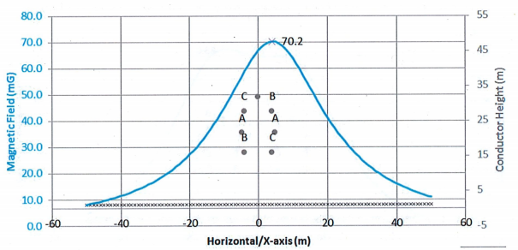

Figure 1: Magnetic field profile when 2L4 only is in service

An identical circuit is planned to be placed next to 2L4 and 2L56 according to the following assumptions:

1. As with 2L4 and 2L56, the new structures between the MCF are steel structures.
2. The distances between 2L4 and 2L56’s structures’ centreline and the new structures’ centreline are 20.6m, since this is BC Hydro’s minimum circuit to circuit clearance separation for steel structures.
3. The maximum conductor sag happens at the same position and at the same elevation as 2L4 and 2L56.
4. The phasing arrangement for the new lines is the same as 2L4 and 2L56, as this is the optimal phasing arrangement to reduce induction levels according to BC Hydro’s standard for controlling induction hazards.
5. The conductors’ spacing is the same as 2L4 and 2L56.
6. The maximum current ratings for the lines are the same as 2L4 and 2L56.

With two identical circuits where each have only one active line, EMF fields are maximised. According to BC Hydro’s calculations, the maximum electric field in this scenario is 1.38 kV/m and the maximum magnetic field is 83 mG (Figure 2), both still well under the limits set by their standards.

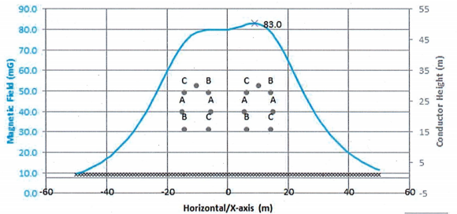

Figure 2: Magnetic field profile for double circuits with one line active for each

Their calculations demonstrate that there are no scenarios under normal operation where someone on the ground near the transmission lines will experience unsafe EMF levels. However, to confirm this conclusion and consequently ease the minds of the workers at this new facility, their exposure could still be tracked with a device like a magnetometer.

### Current Technologies

Electronics is a diverse field where each type of technology plays a different role in making a device work. The sub-categories below describe the core technologies used in our project and what is available for them.

#### Magnetometers and Similar Devices

Magnetometers are tools that measure the magnetic field at a certain point in space and can sometimes give information such as harmonics or how the field intensity relates to another value. An example of an extremely sensitive magnetometer is a SQUID (Superconducting Quantum Interference Device). These devices only work at very low temperatures and therefore require an extreme coolant such as liquid nitrogen [4]. They measure extremely weak magnetic resonances. Due to their specialized nature, these magnetometers are not appropriate for this project.

A more common type of magnetometer is the Hall effect sensor. This sensor typically is an IC package with three pins: supply, ground, and output. The output has a voltage range typically proportional to the magnetic field strength [5]. Some of these sensors do not have very high accuracy within our expected measurement range, so a sensor of this type needs to be chosen with care.

At present, devices called Gaussmeters are on the market. They are a completed product that can measure the EMF strength and display it on its screen, among other features. One such company in this business, Magnii, sells Gaussmeters that are priced in the range of $250-300 USD. Each meter has an EMF measurement range of about 0-250 mG, with a resolution of 0.01 mG [6]. However, in the context of what BC Hydro’s requirements demand, the EMF range is too small (since safety guidelines deal with EMF strength of units of G, not simply hundreds of mG), and the resolution is not as important.

AlphaLab Inc. is another Gaussmeter corporation. One of their meters, the GM2, comes with a maximum resolution of 10 mG with a range of +/- 800 G and USB data logging. However, with the price of $700 USD, it is quite expensive (especially since up to 20 EMF Monitors may be required for the MCF) and the device is overkill for the purposes of this project [7].

The Magnetometer-BLE from IoT-Shops.com is cheaper than the ones mentioned above at 60 €. It is Bluetooth compatible, has a resolution of 1.5 mG, and a range of +/- 50 G. The advantage of being Bluetooth is that the magnetometers could connect to nearby microcontrollers and be powered off rechargeable AA batteries. However, this product is targeted towards monitoring EMF levels of a fixed location instead of employees, since it lacks a screen (to display information to users looking at the module) and has wall mounting (for attaching the device to a building’s wall [8]).

The R-IoT kit from BITalino is priced at 99 € and comes with a USB cable, Li-Po battery and Wi-Fi compatible microcontroller with various built in sensors. The magnetometer in the kit has a range of +/- 8 G and has a resolution of one float [9]. This product could be used to make a device similar to ours, however the kit still requires many other elements to make a fully functional monitor (e.g. a screen, buttons, enclosure, etc.). Moreover, the use of Wi-Fi instead of LTE-M or NB-IoT can be problematic if the device is used in remote locations due to Wi-Fi’s lower reception range [10].

What many of the cheaper Gaussmeters lack is the ability to log measured data in a central database. This feature is quite important in our application since it is useful to view the total employee EMF exposure over their work shift. Furthermore, having a record of EMF levels over the course of a year can give insight into trends in EMF levels (e.g. in certain parts of the year, EMF levels are abnormally high/low).

The main advantage of our project is the customizability. Our product was designed to meet the project specifications (e.g. have the appropriate EMF measurement range) and a data logging system, to consistently take samples of the magnetic field strength, and to be able to provide a report detailing all the relevant statistics of a specified time frame. Our team went for a LTE-M system as the database, so all information can be saved on the Cloud regularly.

#### LPWAN IoT

Cisco Systems defines the “Internet of things” (IoT) as a turning point occurring between 2008 and 2009 where more “things” or devices were connected to the internet than people [11]. Consumer “Smart” devices like the Nest Thermostat, Ring Doorbell and other home automation kits have become prolific as IoT technology has become more affordable. Likewise, IoT has become ubiquitous in commercial sectors, allowing for more intelligent and efficient control at a large scale. Some examples would be energy efficient HVAC control and intelligent supply chain and asset management systems.

LTE-M and Narrowband-IoT (NB-IoT) are two new mobile telephony standards released by the 3rd Generation Partnership Project in 2015 [12]. They are considered to be Low Power Wide Area Network (LPWAN) technologies, which means that they allow long range communications with low power consumption at the cost of low data rates. One advantage that LTE-M and NB-IoT have over existing LPWAN technologies is that they can use existing cellular infrastructure. Telus for example, provides LTE-M and NB-IoT coverage in most of the areas in Canada that they provide regular cell service [13]. The main differences between LTE-M and NB-IoT are data speeds and latency. LTE-M has higher data rates and lower latency which makes it better for real-time applications. NB-IoT has lower data rates and higher latency which makes it more suited for simple static sensor systems. Shown below is an informative graphic (Figure 3) that compares the two and shows possible applications.

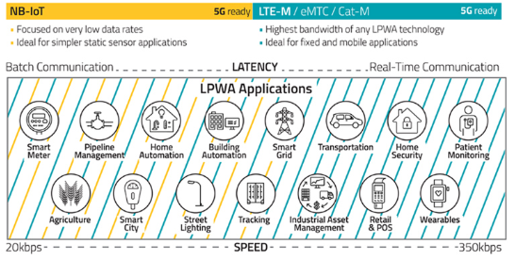

Figure 3: NB-IoT vs LTE-M

As previously shown, current Gaussmeters on the market are not capable of both measuring a wide range of magnetic field strengths and logging the data. Our team wanted the EMF Monitor design to take advantage of emerging LPWAN technology to fill this market gap. By wirelessly transmitting our EMF data, we eliminate the need to design data transfer circuitry/software and can also take advantage of automatically generated analytics from cloud services like Microsoft Azure. To assess the viability of such a design, we used the “Telus LTE-M IoT Starter Kit” (AES-BG96-IOT-SK2-G) which includes a microcontroller, sensor board and LTE-M/NB-IoT modem along with pre-paid data for use on the Telus IoT Network. As an all-in-one IoT kit, it provided the basis for our initial prototype and allowed us to choose between NB-IoT and LTE-M. Moreover, as a microcontroller kit, it allowed us to write all the necessary code in preparation for designing our final product.

## 2.4 Key Literature Summary

Many studies have been conducted in order to determine if a correlation exists between long-term low-frequency EMF radiation and possible health hazards. This topic though, is mired in controversy as some reports suggested there were EMF induced health effects while others found no definitive evidence of such effects [14]. However, based on current literature, the World Health Organization (WHO) found that there was insufficient evidence to prove that long-term low-frequency EMF radiation exposure created health problems [2].

For more short-term health concerns, there are regulations around limiting one’s EMF exposure. Indeed, organizations such as the International Commission on Non-Ionizing Radiation Protection (ICNIRP) state that for EMF created by 60 Hz, the reference levels for the general public and occupational exposure is 2,000 mG and 10,000 mG, respectively [15]. Their guideline’s reference level indicates that limiting one’s EMF exposure below that level “provide[s] protection against adverse health effects” [15, p. 825]. The Institute of Electrical and Electronic Engineers (IEEE) has their own guideline as well. Their exposure limits are “defined to protect against painful electrostimulation in the frequency range of 0 Hz to 5 MHz…” [16, p. 43], and have different values depending on which part of the human body is involved. Their safety levels for magnetic fields are higher than that of the ICNIRP. For example, the 60Hz exposure limit of someone’s head/torso is 9,000 mG, if they are in an unrestricted environment (equivalent to the “general public” level of the ICNIRP) [16, p. 45].

However, according to an analysis done by BC Hydro, the degree of EMF an employee under a power line is exposed to does not exceed 83 mG (for a double transmission line, worst case scenario) [3]. This falls well below the ICNIRP safety guideline’s reference level. Nevertheless, BC Hydro’s analysis is based on classical calculations and not physical measurements. The goal of this project is to provide a tool to accurately measure EMF radiation, allowing users to know whether they are safe from EMF over-exposure or not. This is to give concrete evidence that safety guidelines are being met, and that the calculations based on theory are accurate.

# 3 Scope of Work

This section outlines the objectives our team aimed to complete by the end of the school semester. Longer-term objectives are goals that may be unrealistic for the timeframe given to complete the EMF Monitor, but is where we envision where the product will end up given enough time and effort. The capstone project objectives section discusses the goals we set for ourselves to complete by the end of the semester.

## 3.1 Longer-Term Objectives

Our project can be broken down into three main phase objectives listed below. In a normal project flow, our team would not start the next objective until the current one is completed to a satisfactory level.

1. **Produce a fully functional prototype using the “Telus LTE-M IoT Starter Kit” (AES-BG96-IOT-SK2-G)**

A kit is used in order to quickly meet and verify the core design requirements (EMF measurement, computation of EMF exposure and data storage and analysis) and evaluate the viability of using LPWAN IoT technologies. It will not have an enclosure and will be impractical to use in the field.

1. **Produce an optimized prototype field-testable by BC Hydro employees**

This prototype builds upon the initial prototype. It is where the core features are refined, and other features are added to meet all design requirements. A custom designed printed circuit board (PCB) will be made, and an enclosure will be used.

1. **Refine the optimized prototype into a product able to compete with other Gaussmeters on the market.**

This is where the optimized prototype is modified based on BC Hydro’s feedback. Additional features not mentioned in this document may be implemented and the product make take on a new form factor. The goal is to compete with similar products on the market and expand the potential customer base.

## Capstone Project Objectives

The objectives in this section mirror that of the Longer-Term Objectives section, though a description of what our team hoped to achieve during the semester is listed below each objective.

1. **Produce an initial prototype using the “Telus LTE-M IoT Starter Kit” (AES-BG96-IOT-SK2-G)**

The objective during this phase is to create the core features of collecting 60 Hz EMF data, processing it to some capacity, displaying it on a screen, and having it sent/stored in Microsoft Azure using the IoT kit. Rough solutions are acceptable so long as the features are proven.

1. **Produce an optimized prototype field-testable by BC Hydro employees**

Refinements of previous features and adding new ones should be feasible to complete within the capstone timeframe. However, areas where our team has less expertise (e.g. mechanical design/waterproofing the enclosure) or areas where unexpected difficulties may arise (e.g. properly designing a PCB with all parts on one board) may force compromises on design requirements.

1. **Refine the optimized prototype and perform limit tests on the device**

Making a final commercial product is unlikely to be attempted due to the time constraint of the capstone and being far outside the experience of the team to do. Thus, should the team complete the optimized prototype, further refinements to product features and additional tests (e.g. determining total battery life under different usage conditions) will be done.

## 3.3 Project Execution and Accomplishments

This section describes the accomplishments achieved over the course of the second capstone term. Since COVID-19 caused capstone to end at an important phase in the project’s development, parts of the device that were almost completed, but still had significant progress or some testing done to verify its functionality/ability to meet design requirements, are included in this list with completed items.

By the end of this project, the following items/modules were completed, or nearly completed:

1. A 60 Hz EMF module that measures EMF data, applies a filter to remove higher frequencies, then takes out the DC component to isolate 60 Hz. MATLAB was used to perform an FFT to verify there is a 60 Hz spike in the frequency spectrum.
2. A battery module that safely charges, regulates and monitors a LiPo cell. Statistics such as remaining battery percentage, output current/voltage, and battery temperature are obtainable from the module via I2C communication.
3. A GUI that utilizes three buttons for navigation, LittleVGL to process input/output logic, and an ST7735 screen to show the menu system.
4. A prototype integrating the 60 Hz EMF module and display module (screen displaying the data, not the full GUI menu system) to measure, process, and display the 60 Hz EMF intensity in real time.
5. A PCB design that was completed and ordered for the optimized prototype. It contains traces for a charging circuit, warning LED/buzzer, Micro SD slot, and headers to connect to the GPIO of the microcontroller.

Some changes to the deliverables (relative to what is stated in the proposal) are:

* For item (1), the 60 Hz EMF measurement module, 60 Hz EMF was isolated through filtering, however the measurements produced were not calibrated against a commercial gaussmeter, so the accuracy is questionable. This is because COVID-19 ended the project before the gaussmeter that we ordered could arrive.
* For item (3), the GUI, due to COVID-19 ending capstone early, is just a shell; able to show how the menu would behave when a user interacts with it for most listed configurations, but integration of those settings with their respective modules is incomplete.
* For item (5), the PCB, COVID-19 caused a delay in its shipping and capstone ended prior to its arrival. Thus, assembly of parts with the board and verification of its circuitry did not happen.
* For the optimized prototype, unexpected problems slowed down its implementation before capstone ended early. Various modules for this deliverable were under development, though in isolation (i.e. integration between many modules is not complete). Some of the impacted areas of this prototype include:
  + The Microsoft Azure database was incomplete due to difficulties in separating different device’s data. This module was put on hold during development of the initial prototype for this reason. The compromise being developed was to have internal memory and a way of downloading data via a USB cable (if it was found that using Azure is not viable).
  + The screen chosen for this prototype was not working due to trouble utilizing the ST7565 library with it. Ensuring the new screen worked with the UI aspect was still under progress until the cutoff happened. The compromise would be to use a different screen (e.g. another ST7735 one) if it was found to be too difficult to get the ST7565 screen working.
  + As mentioned earlier, modules were incomplete (e.g. GUI not having all menu items with functionality, or final enclosure not selected from possible enclosures list) and/or unintegrated (e.g. battery management system with prototype). This is due to the above technical difficulties and a shortened timeline.

## 3.4 Collaboration and External Input to Project

Throughout this project, our team consulted various parties on areas of the project we are less familiar with. This section discusses which groups we collaborated with and how that meeting added to this project.

### 3.4.1 BBA Program Review and Consultation

On November 6, 2019, our team met with two Bachelor of Business Administration (BBA) students (Viktoria Feichtinger & Franziska Alber). Earlier, our team sent them a brief summary of our capstone and this meeting was to clarify various questions they had regarding the purpose and scope of our EMF monitor.

According to the report, the main business advantage of our capstone is how our device, although limited in general demand and application, would be of interest to large utility/power companies [17]. As a result, our product is best marketed towards that customer base and customers in a similar field. With BC Hydro as the sponsor and potential interest from other companies, R&D costs would not be of a large concern as they would therefore be covered by the customer. Although the scope of application for the monitor is not large, it is possible to be widened should another company sponsor it (as they may have slightly different needs).

Although our device has competitors in devices that also measure EMF, the transmission of data over the cellular network is one key difference. Moreover, as the device is small and lightweight, transportation of the devices and its composite parts is more easily manageable (lending itself to a leaner supply chain) [17].

### 3.4.2 External Review and Consultation - Design

On November 27, 2019, our team had an external consultation from the MAKE+ group at BCIT’s Centre of Applied Research and Innovation (CARI). In electrical design, we asked questions regarding the difficulty in designing a fully custom PCB for all our components. We were advised that it can be a very difficult design process to get right, especially for high frequency components such as the IoT module. Moreover, if our project were to include high pin density SMD parts (especially if they were of a ball grid array (BGA) design instead of a through-hole design), we would require a professional soldering firm to do the assembly of the board for us. This is because to ensure all the pins on the bottom of the chip were soldered correctly, specialized equipment (e.g. X-ray machinery) is needed. The industry expert knew of some such places locally in Burnaby, though did not provide specific names during the meeting. Taking this advice into consideration, our team investigated IoT modules that are already pre-done, though concluded that modifying the currently used board is best to guarantee compatibility of the board with the rest of the project. This would eliminate the need to complex PCB design work that may be beyond our group’s ability.

In mechanical design, we asked questions about how to make an enclosure more waterproof and shock-proof. For waterproofing options, it was recommended to start with enclosures already rated with a certain degree of water resistance as opposed to trying to do something such as 3D print an enclosure and try to waterproof it afterwards. Moreover, different pre-made options for waterproofing containers was discussed. Such options include the Pelican waterproof case, various Mountain Equipment Coop (MEC) products (e.g. waterproof phone cases, bags, enclosures, silicone pieces for fitting into charging ports, etc.), and dipping the circuit board in epoxy. The advice given in shock-proofing our enclosure was to fill it with foam or filler of some nature, such that drops are dampened and nothing is knocked loose from shock. To incorporate these recommendations, we carried out research into the different kinds of waterproof enclosures available on the market (from vendors such as Digikey and Hammond Mfg.). Furthermore, our team aimed at only using parts that are already waterproof (e.g. waterproof buttons and USB charging ports) where possible instead of looking at trying to waterproof things that were not originally meant to be exposed to water.

### 3.4.3 External Review and Consultation - IoT

While our team was at the CARI building (after our meetings with the Make+ team mentioned above), we also met with Jony Bassan, who was looking at establishing an IoT centre of excellence at BCIT and had several computer science (COMP) students working with him to develop IoT kit instructions. As his team was using the same IoT kit we planned on using for our Monitor, we asked several questions about how to use the kit, problems they had setting it up, and so on. Furthermore, we were given some basic setup instructions developed by the COMP students in using the IoT kit with the Mbed operating system.

### 3.4.4 BC Hydro

Throughout our capstone, we consulted with our industry sponsor, BC Hydro, on clarifying various design details of the EMF Monitor. In addition to the various emails to update them on our progress/ask simple or miscellaneous questions on the design requirements/specs of the EMF Monitor, we had two face-to-face meetings. The first meeting was on October 1, 2019 at the BCIT Burnaby campus. As it was the first meeting with BC Hydro, we got reports on the background information of the project, and documents outlining the analysis done on the EMF output of the facility. Additionally, we narrowed down the specifics required of the project (e.g. clarifying technical details such as how long the device is expected to last until). The second meeting was on December 13, 2019 at the BC Hydro Edmonds office. The meeting acted as both an update of progress on the project and the opportunity to ask questions on some of the matters that we had trouble with at the time, such as if BC Hydro was familiar with what methods are available to isolate 60 Hz EMF radiation from the spectrum.

# 4 Project Implementation

This section describes the work completed over the school year, the difficulties faced when implementing certain features, and the reasons for failing to complete all objectives set in the proposal. This section first discusses a high-level overview of the project and how the different sub-systems within the EMF Monitor interact with each other in (4.1 High-Level Description). Next, (4.2 Design and Implementation) describes the details of how the capstone project was designed, troubles in the design process, what was implemented, and what was not implemented due to the COVID-19 situation or technical challenges. Finally, (4.3 Results, Testing, and Verification) talks about what sort of testing went into ensuring the EMF Monitor’s features did what we intended them to (and to the extent we want them to), the results from those tests, and difficulties experienced along the way. Each section may be further divided by whether a certain module was developed during the “initial prototype” phase or the “optimized prototype” phase if it is appropriate to make such a distinction.

## 4.1 High-Level Description

From a high-level perspective, the EMF Monitor was meant to use a magnetometer to measure EMF data, which would be processed by the microcontroller to isolate the 60 Hz component, then store that information in an SD card and/or sent to a central database through an IoT module. The user input consists of buttons, and the system output is done through a screen and buzzer. A rechargeable battery and its corresponding charging circuit is utilized to power the device/recharge it via USB. When plugged in to a computer, the user would be able to extract the EMF data stored on the EMF Monitor by using a custom program, then have that information put in an Excel sheet.

Due to the COVID-19 virus causing BCIT to shut down capstone projects prematurely, the implementation of some of the aforementioned modules, finer details/features of them, and/or integration between them were not fully completed (with certain areas suffering more than others). A breakdown of the EMF Monitor into all its intended sub-systems is shown in (Figure 4):

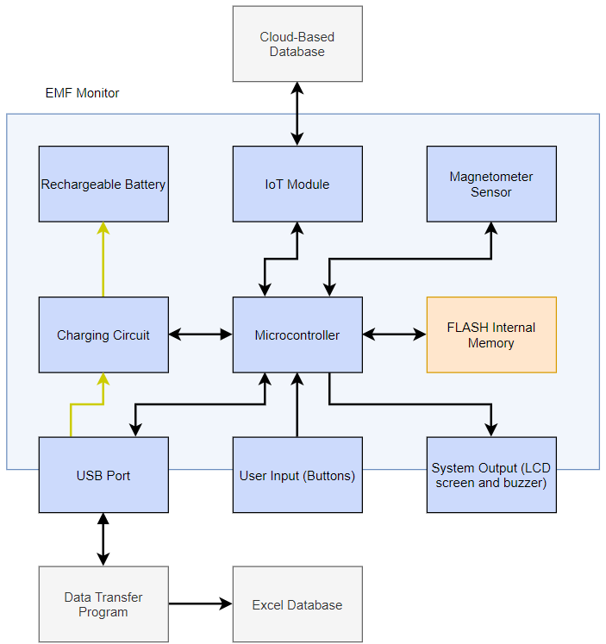

Figure 4: Sub-system breakdown of EMF Monitor

The different colors of the blocks comprising the EMF Monitor are:

* **Blue**: Modules that were planned on being implemented since the capstone proposal
* **Orange**: Modules added since the proposal
* **Grey**: Modules that little to no progress was made on

*Note: Blue blocks are not necessarily complete, however, the team was able to put significant progress/work into them.

### 4.1.1 Microcontroller

The microcontroller is the brains of the device that manages the inputs/outputs and overall device logic. When the device is powered up, the microcontroller first initializes the various hardware modules. In addition to setting up variable’s initial values/recalling saved values and connecting to the cloud-based database through the IoT module, the magnetometer, battery charger board, and screen need various registers to be configured (e.g. for the magnetometer to sample at a certain rate) a certain way.

After initializations, the EMF monitor is ready and is waiting for the user to press one of the menu-navigation buttons. However, in the background, the microcontroller is continuously receiving data from the magnetometer and processing it. The table below, (Table 1), shows all the threads managed by Mbed, the real time operating system running on the microcontroller.

|  |  |
| --- | --- |
| Thread Name | Purpose |
| Mag_sensor_thread | * Initializes I2C and configures the MMC5603NJ * Takes EMF measurements at fixed time intervals and then process the data. * If not connected to Azure, writes measurements to SD Card every minute. Otherwise, signals the Azure_client_thread to transmit the data. |
| Ticker_task | * Provides the UI_refresher_task with timing and sets the UI update rate |
| UI_refresher_task | * Handles updating dynamic UI values. When a value is changed, the GUI library, LittleVGL, knows to redraw that UI element and communicates that change to the display over SPI |
| Azure_client_thread | * Checks that the BG96 board has been initialized on and attempts to connect to the Telus network on startup. * Sleeps until signaled by Mag_sensor_thread, then establishes a connection with Azure IoT Central and transmits the data |

Table 1: Mbed Threads Ordered by Descending Priority

### 4.1.2 Magnetometer Sensor

This module consists of a three-axis magnetometer, the MMC5603NJ, on its breakout board (Figure 5). It is responsible for measuring the magnetic field strength and communicates with the microcontroller over I2C.

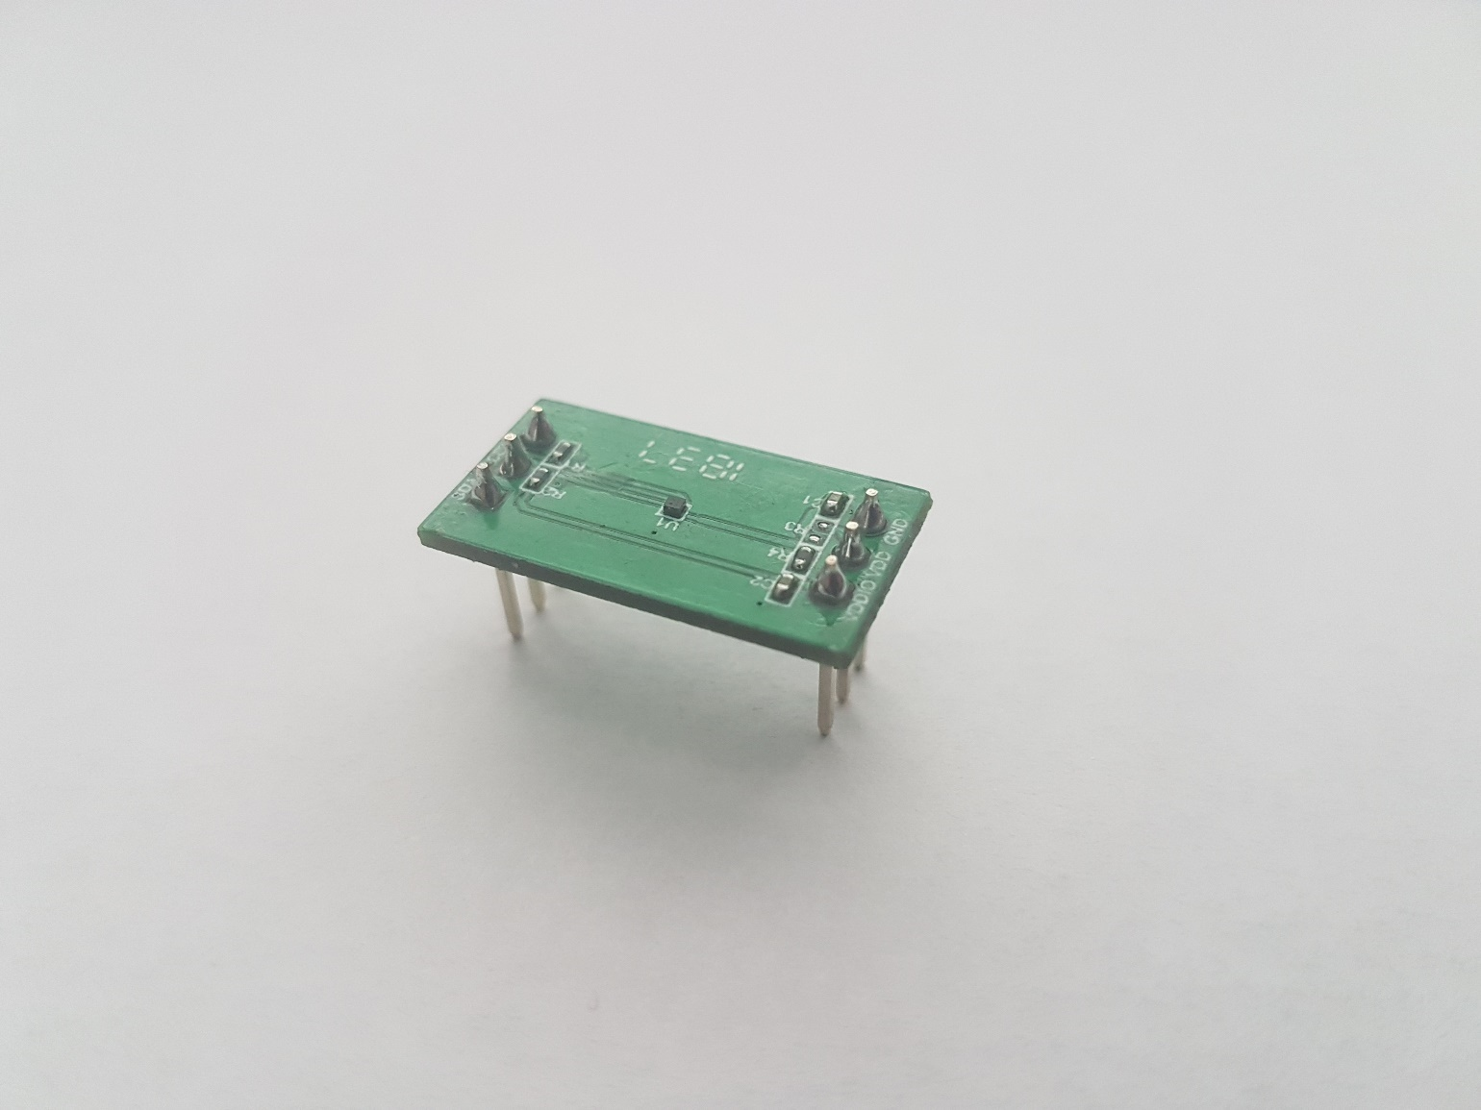

Figure 5: MMC5603NJ breakout board

The sensor is controlled and configured by the “Mag_sensor_thread” which is visualized as a flowchart in (Appendix A: Magnetometer Sensor Thread Flowchart). After doing some initial configuration, this thread sleeps and waits for a flag to be set by a hardware interrupt. When set, this flag signals the sensor to take a measurement. The frequency at which this flag is set determines the sample rate of the sensor. Once the measurement is completed, it is retrieved by the microcontroller, processed through a FIR filter to isolate the 60 Hz component and added to an array. When the array is full, a mutex is locked (this is to prevent the UI thread from accessing the current EMF value while it is updating) and the RMS value of the array is taken and used to update the currently displayed EMF value on the display of the device.

### 4.1.3 User Input

The user input consists of several momentary, normally-open buttons. Three buttons are for navigating/interacting with the screen’s menu (“left”, “right”, and “enter”), one button is for power, and another button is for toggling the backlight. A fourth user button may be added in the future, and the power/backlight button was unable to be implemented prior to end of the shortened capstone term.

The microcontroller checks whether a button is pressed using interrupt service routines that trigger whenever the voltage of the button’s pin transitions from 3.3 V to 0 V (since pull-up resistors are used, this type of transition denotes a button press). Debouncing is done in software by checking the pin’s state after a set time from the first voltage transition of the input pin. A button press is registered as one by the microcontroller only if the pin logic after the debounce time is “low”. This information is fed into the menu system so it can change the display accordingly.

### 4.1.4 System Output

The outputs of the device are a buzzer and screen (though the buzzer was not yet implemented). Additionally, an RGB indicator LED was under considered for output but also unable to be implemented due to being a low priority item. Although the microcontroller can use the buzzer or LED directly (setting the pin high/low with an in-line resistor will activate/deactivate the component), driver software is needed to interface with the screen (e.g. to tell the screen which part of it is being changed, what color it is set to, etc.). Whenever the microcontroller finds that the measured EMF intensity exceeds a set threshold, it sets the buzzer pin high, alerting the user.

The screen requires a driver software library for the microcontroller to properly interface with the screen and send information to it. The screen used for the initial prototype uses the ST7735 IC, which is controlled with SPI. The screen that would be used for the optimized prototype used the ST7565 IC, which also uses SPI, though adapting a driver library to utilize it was still in progress when capstone ended. The menu system used with the screen is managed by a GUI library called LittleVGL. Updates to dynamic values on the screen are done through the “UI_refresher_task”. During set intervals, LittleVGL checks to see if any part of the screen needs updating, and if so, tells the screen driver software to update that part of screen. A thread called “Ticker_task” is triggered periodically, which tells LittleVGL how much time elapsed since the previous time update, allowing it to judge whether it should update the screen again.

The screen is for displaying the current, maximum, and average EMF data measured by the magnetometer. Other information, such as how much battery life is left, has placeholder variables implemented due to being unintegrated with its respective module. The menu system aspect of the UI allows the user to navigate between seeing the EMF data or going into a settings menu to change the device’s configurations. Configurations for the device include whether LTE is enabled, what units the device displays, and whether a magnetic or electric field is measured. The full list of configurations and the menu system is organized is discussed in (4.2.1.5 User interface). Like the other information displayed on the screen, the menu items are also still placeholder fields that are unintegrated with the module(s) that would use that setting (due to the capstone term being shortened). However, most menu items do respond to user interaction (e.g. they display a value being toggled when the “enter” button is pressed when that option is selected).

### 4.1.5 IoT Module

The IoT module in our device is the Quectel BG96 modem board, shown in (Figure 6). This is what allows us to transmit our EMF data to Azure IoT Central and is controlled by the “Azure_client_thread”. The BG96 communicates with the microcontroller serially via the UART but also has a stand-alone operation mode where the user can configure it with “AT” commands using its dedicated micro USB port. This module spends most of its time in a low power sleep mode until the microcontroller instructs it to power up and begin transmitting data. For our prototype, we used the Telus LTE-M network to connect to Azure. Other network providers can be used by swapping out the SIM card.

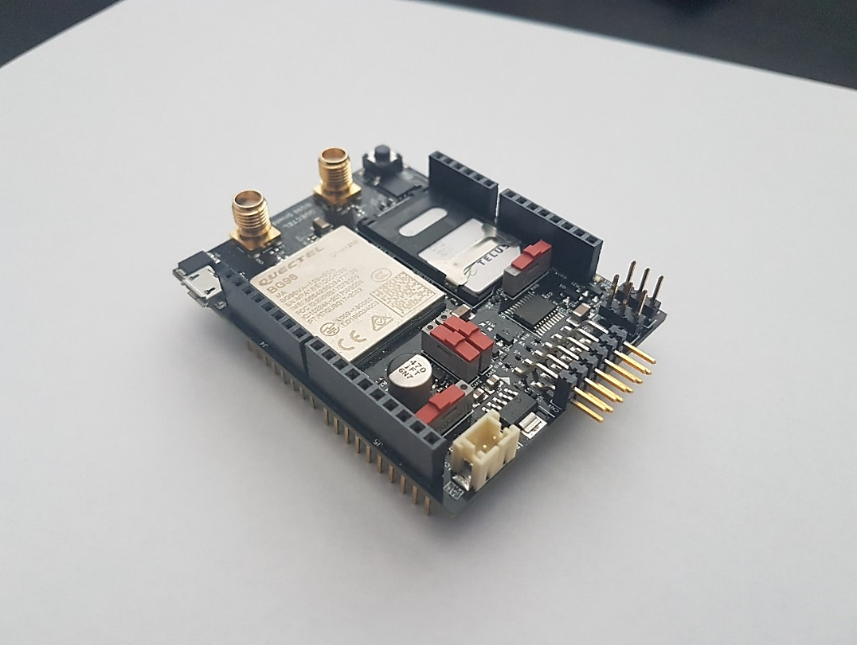

Figure 6: Quectel BG96 modem board

### 4.1.6 Internal Storage

If no LTE-M connection has been established, measurements would be periodically saved during the “Mag_Sensor_thread” to a MicroSD card (Figure 7). These measurements are stored in plain text in a FAT filesystem and are transferred from the microcontroller using the SPI interface. This module of the project was largely left incomplete for reasons described in (4.2.2.1 Internal Storage). We were able to format the SD card and write data to it from the microcontroller but did not fully integrate it with the other modules in our device.

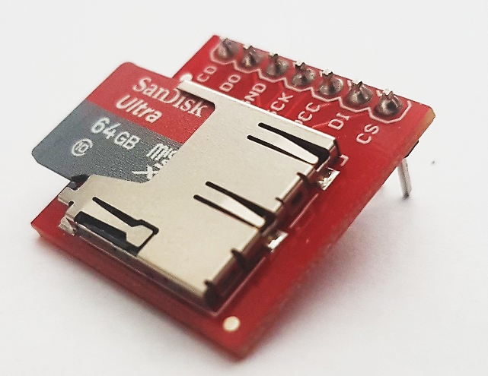

Figure 7: Sparkfun MicroSD breakout board

### 4.1.7 Database and Data Transfer

This is another module of our project that was largely left incomplete. Originally, we had planned to use Azure IoT Central both as our database and as a device management tool (Figure 8). Our device would be able to transmit EMF measurements to it and would also be able to receive data like updated employee lists or new firmware. For reasons stated in (4.2.1.3 Azure IoT Central), development on this was paused and we shifted our focus to a non-cloud based solution.

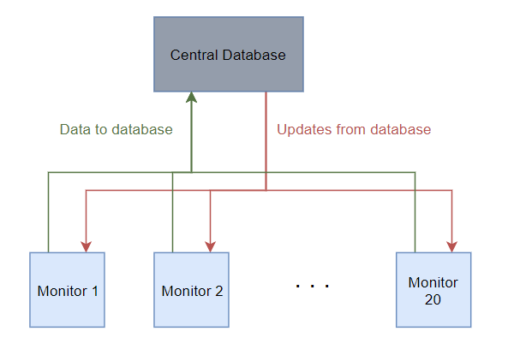

Figure 8: Monitors connected to a cloud-based database

This new solution would have been using the SD card as our on-device storage, and then using Excel spreadsheets for external storage and data analysis. Data transfer from the device would occur over a USB cable and be handled by the Python application described in (4.2.2.1 Internal Storage).

### 4.1.8 Battery and Charging

It was important to be able to safely charge, discharge, and monitor the battery without removing it from the enclosure. Many charging circuits are available, but we chose the Sparkfun Battery Babysitter because it had every feature one needed for charging a LiPo cell. Furthermore, it used the I2C based BQ27441 IC, which had many monitoring functions (such as showing remaining capacity). Since Sparkfun provided the full schematic for the board on their website, unused features (such as configurable charging current) could be hardwired when designing the PCB for the optimized prototype.

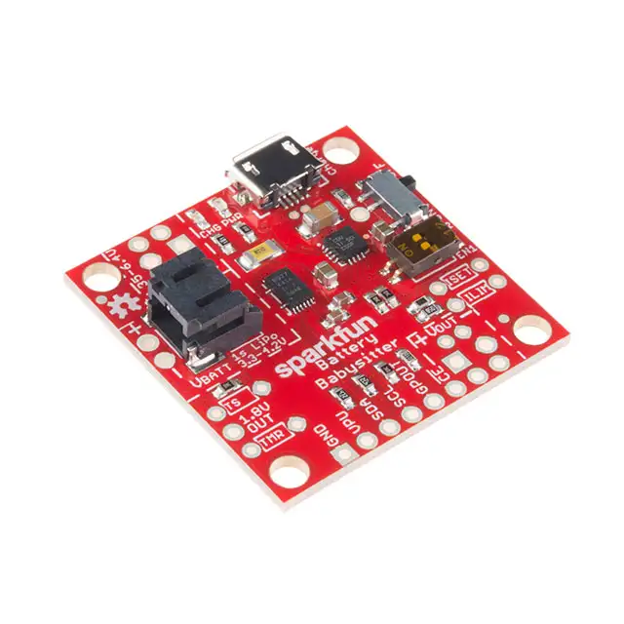

Figure 9: Sparkfun Battery Babysitter

On the Battery Babysitter board, the micro USB port is only used for power (to charge the battery) and has no data transfer connections. The large black connector is for the LiPo cell. The battery can be charged and discharged from the one connector. The metallic slide switch controls whether the battery can output any power. The pair of plastic slide switches control the charging current but were always left on their default minimum position which corresponded to 100 mA. By flipping the switches, one chooses the charging current to be 500 mA, ILIM (customizable), or off.

These switches connect to the EN1 and EN2 pins of the BQ24075 IC which regulates the charging of the battery. It determines how much voltage and current to supply to the battery based on the battery’s voltage. There are many features available for the IC which were overkill for our applications, including adjustable timers, thermistor inputs, and customizable charge currents.

The BQ27441 is a very robust battery monitoring IC with many functions. LiPo cells have a nominal voltage of 3.7 V but this voltage varies with charge. The IC measures this voltage directly and measures the current from the battery via a 10 mΩ sense resistor and uses these numbers to calculate the battery’s parameters. SDA and SCL then facilitate the I2C communication with the microcontroller.

## 4.2 Design and Implementation

This section describes what was implemented for each module of the EMF Monitor, the design considerations/tradeoffs put into various features/parts, and challenges encountered in the design process. The modules are grouped in order of first appearance (e.g. a module was started during the initial prototype vs. the optimized prototype).

### 4.2.1 Initial Prototype

The “Telus LTE-M IoT Starter Kit” (Figure 10) was chosen to be used for initial prototyping. It consists of a NUCLEO-L496ZG microcontroller, X-NUCLEO-IKS01A2 sensor board and Quectel BG96 modem board. This kit was chosen as an “all-in-one” solution to allow us to rapidly develop code that could be re-used with our optimized prototype.

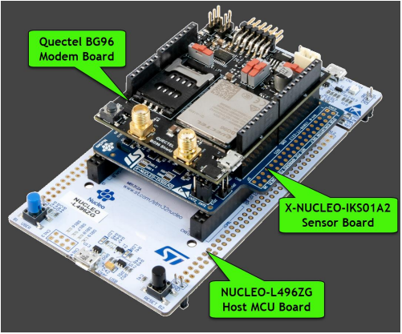

Figure 10: Telus IoT kit for initial prototype

The STM32L496ZG microcontroller, with 1 MB of flash memory and an 80 MHz CPU, would be powerful enough to run a simple graphical user interface (typically requiring ~100 kB of flash and at least a 20 MHz CPU) while measuring and preforming signal processing on EMF data in real time. If we found that we had a lot of unused memory and CPU cycles, we could downgrade to a cheaper microcontroller for the optimized prototype. Ideally, we would eventually replace the NUCLEO board with our own PCB and just use the STM32 microcontroller and magnetometer that we ended up selecting.

The IKS01A2 contains an LSM303AGR magnetometer which can measure +/- 50 G magnetic fields with a sensitivity of 1.5 mG. In terms of magnitude, this seemed sufficient as we only expected to encounter magnetic fields with a maximum strength of approximately 80 mG and needed to at least be able to measure up to 2000 mG (BC Hydro’s safety limit). However, we did not know if it would be able to isolate 60 Hz EMF. The Nyquist-Shannon sampling theorem states that in order to accurately sample a continuous time signal without aliasing, you must sample it at a rate of twice its bandwidth. This means that we must sample the EMF at least 120 Hz if we want to measure the 60 Hz component. According to the datasheet, the sensor could achieve a sampling rate of 150 Hz, but only if the sensor were in low power mode and the measurements were triggered manually. We expected that we would need to upgrade this sensor for the optimized prototype. However, for the purposes of making an initial prototype, this sensor was deemed to be acceptable.

The BG96 modem board would provide us with LTE-M or NB-IoT connectivity which would allow us to send EMF measurements to Azure IoT Central for storage. It also featured GPS connectivity, which we did not plan on implementing in the initial or optimized prototype, but we anticipated that it might have uses in the final commercial product stage. As mentioned in (3.4.2 External Review and Consultation - Design), due to the complexity of designing our own PCB for the modem, we planned instead to make small modifications to the BG96 to reduce its vertical profile. Specifically, we could replace the SMA antenna connectors with 90-degree connectors and desolder any unused components.

Do note that for the initial prototype, not all features were fully implemented or fleshed out. This is due to unexpected difficulties in developing some of the modules (explained in more detail in 4.3 Results, Testing, and Verification) and COVID-19 causing BCIT to end capstone prematurely. One of the areas of implementation that suffered the most due to COVID-19, is the integration of modules. Although the core module functions are integrated with each other (e.g. measuring EMF data, processing it, then displaying on the screen), the less key module features were not.

#### 4.2.1.1 RTOS and Development Environment

Upon receiving our Telus IoT kit, we were initially unsure on how to proceed. We had assumed that the kit would include some basic documentation and example code for connecting to the Telus network. This was not the case. Luckily, after our conversation with Jony Bassan (3.4.3 External Review and Consultation - IoT), we were provided with some sample code and instructions for getting sensor data from the kit and uploading it to Azure IoT Central. This sample code used “Mbed”, an open source real time operating system (RTOS) intended for IoT applications. It has built in hardware abstraction layers for many microcontroller platforms, allowing developers to write higher level C++ application code (instead of pure C) in an embedded environment

(Figure 11). Given that Mbed had built in support for our microcontroller and our sensor and modem boards, we chose to use it for the remainder of our project.

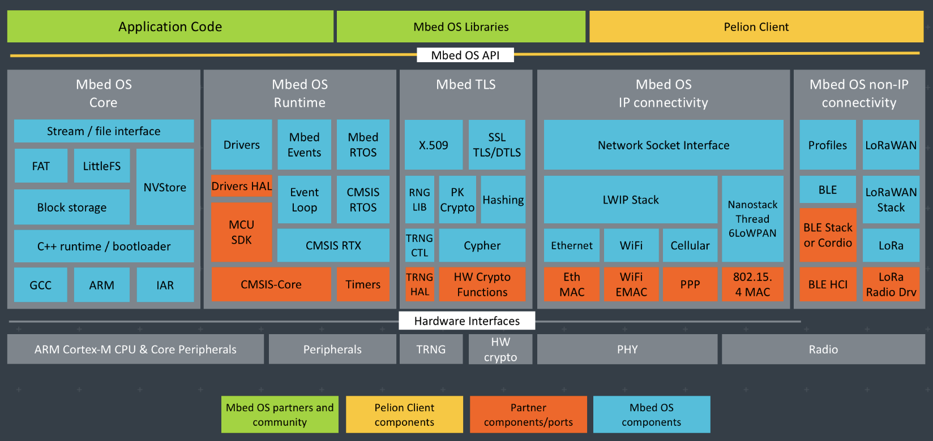

Figure 11: Mbed board architecture

Mbed can be paired with a matching integrated development environment (IDE) called “Mbed Studio” which can auto-detect microcontroller platforms and setup debugging accordingly. This would have been our IDE of choice; however, it is still in public beta and does not fully support import of all previously created Mbed projects. We attempted to import our sample code into Mbed Studio and were not able to compile it. As a result, we instead settled with using an IDE called “Visual Studio Code” and compiled our project through command line. One downside of this was that we had to manually setup hardware debugging for our microcontroller. We attempted to do this several different ways over the course of the project but ultimately could not get it to work.

#### 4.2.1.2 60 Hz EMF Measurement

Our strategy for measuring 60 Hz EMF was to use a form of real-time digital signal processing. Specifically, we implemented a finite impulse response (FIR) filter which we used to isolate a particular frequency range of the sampled EMF signal. This filter (Figure 12) was designed using MATLAB’s filter designer app.

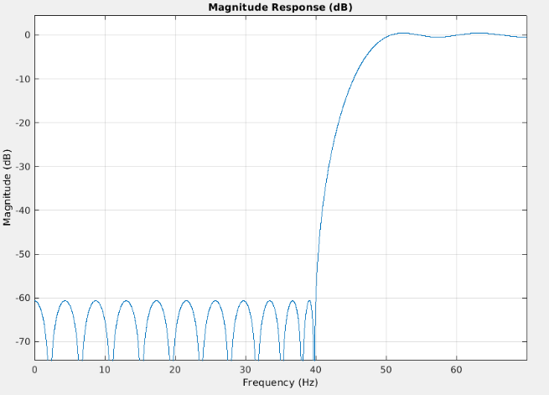

Figure 12: FIR filter frequency response

We entered in a desired cut off frequency of 50 Hz and stop band attenuation of -60 dB and MATLAB generated a set of filter coefficients. A cut off frequency of 50 Hz was chosen initially because we were not sure how wide the energy spike at 60Hz would be. To implement the filter on our device, we instructed our RTOS to generate a hardware interrupt every 7 ms (this corresponds to a sample rate of ~140 Hz) which would trigger our sensor. The sensor would then take three measurements, one for each axis. The magnetic field vector sum was then computed as follows:

$$H= \sqrt{H_{x}^{2}+H_{y}^{2}+H_{z}^{2}}$$

This value was then stored in a circular buffer of the same length as our number of filter coefficients. Whenever a new value was stored in the buffer, a filtered EMF value was produced using:

$$y\left[n\right]= \sum_{i=0}^{N}{b_{i}}∙x[n-i]$$

Where *y* is the output, *bi* are the coefficients, *x* is the vector sum inputs from the buffer, and *N* is the filter length. This can also be shown graphically using a block diagram (Figure 13).

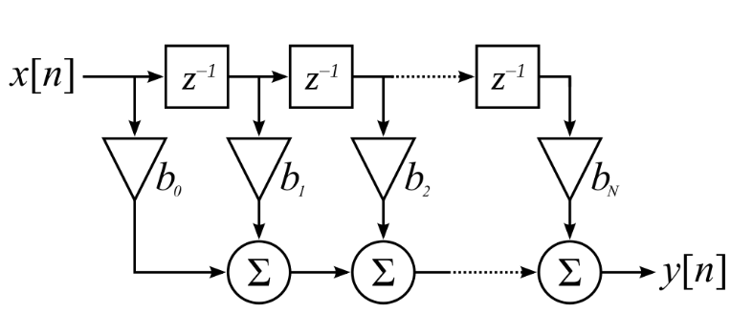

Figure 13: FIR Filter Block Diagram

The filter output was then collected into an array. Approximately every 300 ms, the RMS magnetic field value of the array was computed and used as the final measurement:

$$x_{RMS}=\sqrt{\frac{1}{N}\sum_{i=0}^{N}{x_{i}^{2}}}$$

Where *xi* are the filtered magnetic field strengths in the array and *N* is the array length. As per design requirement (1.4), one measurement per second is the minimum update rate. 300 ms was chosen as we wanted our device’s measurement to update fast enough for the user to be able to tell how the field strength was changing with their position, while still averaging enough 60 Hz cycles so that the value would not jump around continuously. The array length could always be adjusted later based on feedback from BC Hydro.

As described later in (4.3.1.1 EMF Sensing), our LSM303AGR sensor was not sensitive enough to 60 Hz EMF. This required us to select a new sensor for testing. Ultimately, we decided on the MMC5603NJ. Its datasheet states that it has a “true frequency response up to 1 kHz” and has a much higher sensitivity than the LSM303AGR. A comparison of the sensors is shown below in (Table 2).

|  |  |  |
| --- | --- | --- |
|  | **LSM303AGR** [18] | **MMC5603NJ** [19] |
| Measurement Range (G) | +/- 50 | +/- 30 |
| Max Sensitivity (mG per LSB) | 1.5 | 0.0625 |
| Max Bits per Measurement | 16 | 20 |
| Max Sample Rate – Manual (Hz) | 150 | 1000 |
| Max Sample Rate – Automatic (Hz) | 100 | 255 |
| Average Current Draw (μA) | 100 | 1500 |

Table 2: LSM303AGR vs MMC5603NJ

One downside of the MMC5603NJ was that there was no pre-made code available for it like with the LSM303AGR. This meant that we had to write our own low-level library code that would abstract away the process of reading and writing to registers over I2C. Luckily, our experience with low level C from ELEX 3305 (Microcontroller Systems) and ELEX 7820 (Real-Time Embedded Systems) allowed us to do this quickly without any major issues.

#### 4.2.1.3 Azure IoT Central

Another advantage of using the Telus IoT starter kit was that it came with $250 of credit towards Microsoft Azure services. Azure is a cloud computing service which offers various products under the “software as a service” model. As per design requirements (6.0) and (6.1) [20], we needed a database that could hold exposure data for up to 20 employees and provide visual trending and analysis of their exposure data. At the time, “Azure IoT Central” seemed like a good choice. IoT Central is a scalable IoT application platform with a web-based UI (Figure 14) that allows the user to monitor and manage devices, generate analytics, and setup automated “rules” that can trigger on certain events.

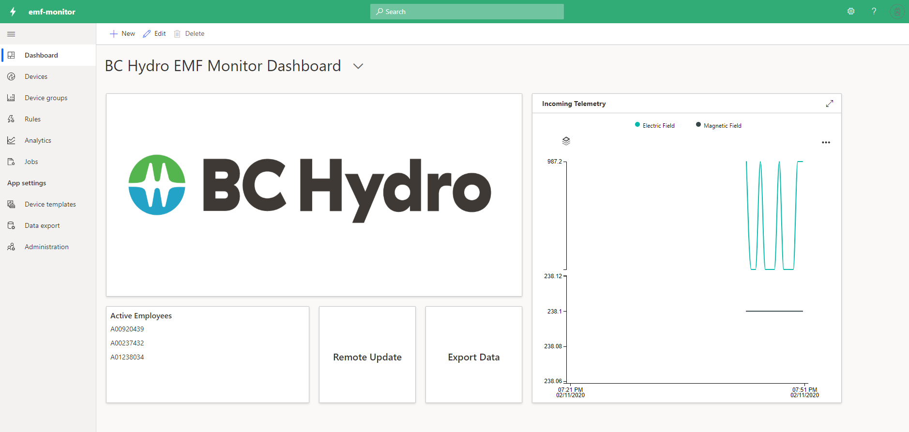

Figure 14: Azure IoT Central app mockup

We envisioned that IoT Central would allow BC Hydro managers to easily browse through data and be automatically notified if any employee were overexposed. Additionally, any firmware updates for our device could be pushed wirelessly, completely removing the need for any form of wired data transfer. The simplicity of this solution was one the major reasons we decided to incorporate IoT technology into our device. However, IoT Central turned out not to be the all in one solution that we had hoped for.

We wanted BC Hydro employees to be able to pick-up any available EMF monitor at the start of their work shift, login, then begin working. However, we found that there was no way for IoT Central to distinguish one user of a device from another in its analytics. It could filter and separate data from different EMF monitor devices but could not track the exposure of a user across multiple devices. This would restrict the use of a particular EMF monitor to a single employee which is not acceptable. The solution was to use the built in “continuous export” function which would output incoming data in a JSON format. This output could then be connected to a chain of other products like Azure Event Hubs, Azure Service Bus or Azure Blob Storage where more complex data filtering can be performed. However, running these services increased costs greatly. IoT Central alone allowed up to two devices to be connected for free which was very convenient for testing. When we added continuous exporting and ran our prototype for a few minutes we were charged $5 for our use of Azure services. This would make testing very inconvenient and would not be economically scalable if we wanted to support many devices. We decided to put our IoT development on hold while we researched possible solutions.

#### 4.2.1.4 Battery

To meet the power needs of our project, a LiPo battery was chosen due to its high-power density – an important consideration when we had the space constraint of fitting everything in a pocket-sized enclosure. Another reason for choosing specifically a LiPo battery is that it is popular for powering electronic hobbyist’s mobile projects. This meant that many electronics vendors, such as SparkFun, had small and compact boards to charge these types of batteries from a USB port. This saved our team the effort of developing our own battery charger circuit from scratch or using bulkier or non-mobile battery charging systems. To determine the capacity of the battery, a calculation of the worst-case current draw was done, and is shown in (Table 3).

|  |  |  |  |
| --- | --- | --- | --- |
| **Component** | **Worst-Case Current Draw**  **(mA)** | **Time Active**  **(hours)** | |
| NUCLEO-L496ZG (Microcontroller) | 8.64 [21] | 8 | |
| MMC5603NJ (EMF Sensor) | 4.0 [19] | 8 | |
| 64128N FC BW-3LP (Screen) | 20.5 [22] | 1 | |
| BG96 (Modem Board) | 205 [23] | 1 | |
| **Total Current Draw for 8 Hour Shift (mAh):** | | **327** |

Table 3: Battery capacity requirements for 8-hour shift

Thus, 1000 mAh was chosen as the battery capacity to have a significant amount of additional capacity. Since the display and modem would operate intermittently, a conservative estimation was made on their active hours. It would be unlikely for employees to keep the display on with the back light enabled for more than an hour per shift. As for the modem, it would spend most of its time in a low power sleep mode with intermittent high-power bursts to establish a connection and transmit data. Realistically, it would be active for a much shorter amount of time than one hour, but we did not test the modem’s power draw at the time of this calculation, so we thought it would be better to overestimate. Our design requirement was for the device to only operate for 8 hours; however, we did not see any benefit in choosing a smaller battery. The size of the optimized prototype would be limited by the profile of the BG96 modem board and since the 1000 mAh battery was already smaller than it, there would be no size reduction of the device from a smaller capacity battery.

To measure battery capacity and handle the charging process, the SparkFun Battery Babysitter board was chosen due to its compact size, reasonable price, and pre-existing library for using it. Bhavik was tasked with working on this board because he needed to understand its operation in order to replicate it on the custom PCB. It was simple enough to solder on its headers and use it on its own to charge and regulate a LiPo cell, however it was difficult to get the I2C communication between the Battery Babysitter and the NUCLEO board. Bhavik consulted Reza privately and the other capstone team members and finally found an Mbed microcontroller library specifically for the BQ27441 (the battery gauge IC).

Many commands are available from the IC (Table 4) however, we were only interested in the StateOfCharge(), as this value could be directly displayed in the UI to let the user know the remaining charge as a percentage. Other values such as the instantaneous output voltage, remaining charge in mAh, etc. are irrelevant to the end user.

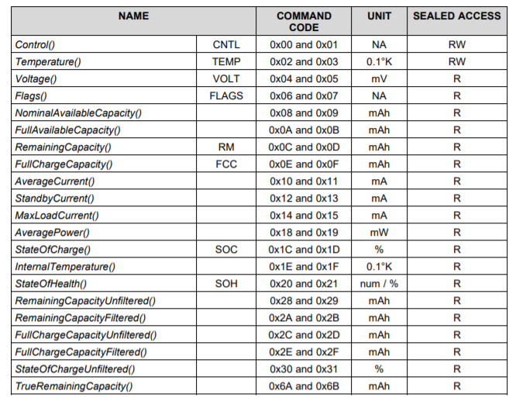

Table 4: Standard commands for BQ27441

#### 4.2.1.5 User interface

To interface with the EMF Monitor, a set of normally open push buttons and an ST7735 128x128 pixel TFT color screen were used as the input and output. The buttons are debounced in software by checking the pin logic level after a set time passes after the button is pressed. Debouncing was not done in hardware to cut unneeded costs, and because implementing debouncing using timers (instead of delays) ensures the program can operate unhindered by the extra process.

For the microcontroller to communicate with the screen, a software library for controlling ST7735 screens (made by Roland Kamp [24]) was modified to work in the context of our specific project. The screen displays various pieces of information, such as the current, maximum, and average EMF values within a GUI. This menu system is handled by a C++ GUI library called “LittleVGL”. A “left”, “right”, and “enter” button are used to navigate the menu and change values.

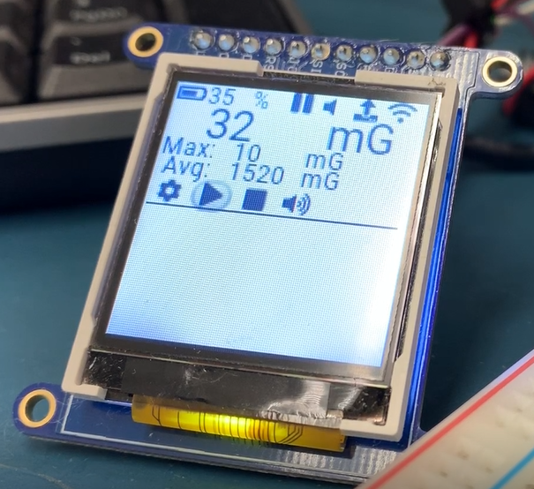

Figure 15: EMF Monitor main screen display

(Figure 15) shows the intended “main screen” of the EMF Monitor with dummy values entered. The reason for only the top half of the screen being filled was for aesthetic purposes; our team found that a more rectangular screen for our EMF Monitor looked better, so the menu was arranged to accommodate this in anticipation for the screen selected for the optimized prototype.

The top bar, from left to right, shows:

* **Battery life**: what percentage of battery remains (voltage measured from SparkFun Battery Babysitter). As battery life is a slow changing value, a global variable is used to store the battery life and automatically updates the screen when it changes.
* **Work-shift recording**: Displays a “play”, “pause”, or “stop” symbol depending on if the EMF Monitor is currently recording EMF values, is paused recording values but is still in the same recording session, or is not recording (recording session ended).
* **Buzzer volume**: When the measured EMF value goes over a set threshold value, a buzzer is sounded to alert the user that their EMF exposure is too high.
* **LTE upload**: This value indicates whether the EMF Monitor is configured to send values to Microsoft Azure through the LTE network, or if values or only to be stored locally.
* **LTE availability**: This shows whether the EMF Monitor was able to connect to Microsoft Azure or not (shows if an LTE connection is available).

For the above parameters, flag(s) are used to represent the state of that item. However, integration of those flags with the modules they are supposed to change the program flow of was not completed. In the case of battery life, integration between measuring the battery voltage from the SparkFun Battery Babysitter and the global variable is also not done, though is trivial to complete.

The three values in the middle of the screen (between the top and bottom set of icons) are the current, maximum, and average EMF values. The values on the screen update themselves when a global variable for those values are changed. Integration with the current EMF value and the magnetometer module was completed. The maximum and average EMF values would be used when a session recording is started (i.e. they show the maximum and average EMF values for the current recording).

The bottom bar, from left to right, are menu icons to change:

* **Settings (gear)**: Go to the settings menu screen to change the EMF configurations.
* **Play/pause**: Start a new recording session (or continue a paused one) to record EMF values. When pressed, the icon changes the “pause” symbol and the top bar icon is updated to the “play” symbol. Pressing this icon again pauses the session, changes the icon to the “play” symbol and makes the top bar have the “pause” symbol.
* **Stop**: Stops and ends the current recording session. The top bar icon is changed to the “stop” symbol and the play/pause icon is set to the “play” icon (if it was the “pause” symbol).
* **Buzzer mute/unmute**: Pressing this icon toggles this icon and the top bar icon between a muted speaker and an unmuted speaker (representing the fact that the buzzer is muted or unmuted).

The bottom bar items are software buttons that the user can move between or select by pressing the “left”, “right”, or “enter” buttons mentioned earlier. In terms of designing the main screen, our team decided on which items would be most important to be immediately available to the user and placed them on this screen. Features that the user may want immediate access to (e.g. recording and mute) are also placed on this page. Other information or configuration features that are less important/less often changed are then displayed when the user goes into the “settings” menu page.

One design choice that may need to be changed in the future is the top bar vs. bottom bar icons. For the play/pause/stop and mute/unmute buttons, the icons on the top and bottom are opposite to each other. The reasoning for this is that the top bar shows what state the device is in right now, whereas the bottom bar acts as a “the user chooses to change the configuration setting to this”. Since this aspect of the menu may seem confusing to users, changing the bottom button icons to be static symbols was under consideration. Our team decided that our device should have a small number of buttons (e.g. no keypad) to avoid over-complicating the interface. Therefore, we chose to have three buttons to navigate/change the menu configurations (with consideration to having a fourth button if the end user found the interface to be too clunky), a button for toggling the screen backlight, and a button for turning on/off the device. The backlight and on/off button were not completed due to the other features being considered more important to finish first. Another UI element that was desired but not completed was a screen “time out” mode, where if no button is pressed for a given time, the screen turns off to save power. The screen would then re-activate upon the next button press.

When the “settings” button on the bottom bar is pressed, the settings menu screen is displayed on the screen:

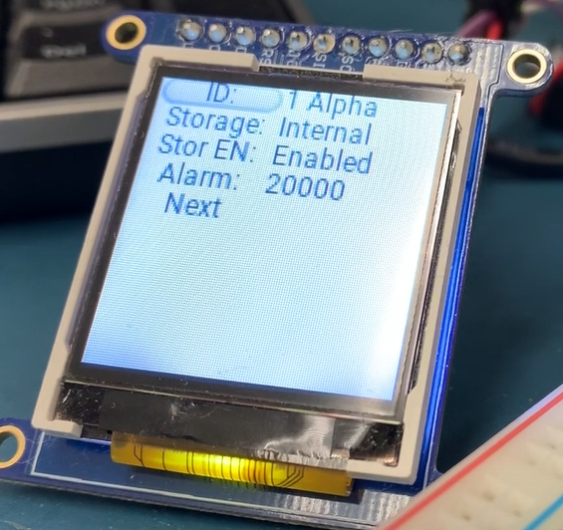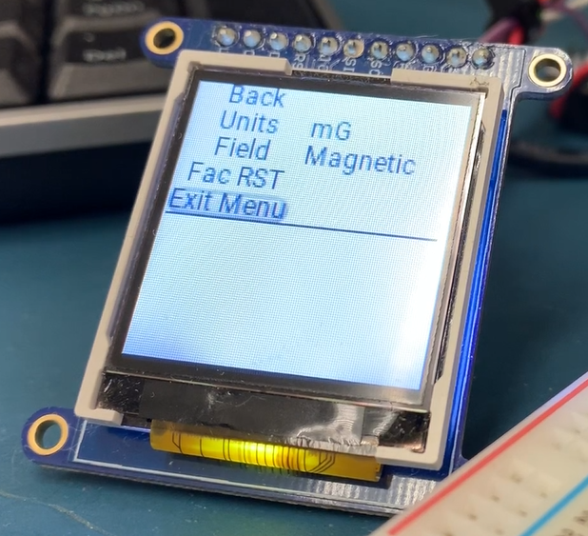

Figure 16: Settings menu one (left) and two (right) for EMF Monitor

(Figure 16) shows the configurable settings for the EMF Monitor. The settings are as follows:

* **ID**: Select a name to differentiate between EMF recordings from different devices/employees. Pushing “enter” with this menu item selected toggles between a list of ID’s stored in the device. Our team intended the name list to be changeable from Microsoft Azure or when the device was plugged in, though that feature was still undeveloped by the closure of capstone. If implementing that feature was too difficult, the alternative is to have a preset name list for the expected number of end users.
* **Storage**: Choose between storing EMF recording data only locally, or locally and on LTE. Changing this icon also changes the “LTE upload” top bar icon on the main screen page.
* **Stor EN (storage enable)**: For manually turning on/off the LTE module if the user wants to save on power or does not need the LTE connection. “Store EN” was the name used when developing the menu and would be changed to “LTE EN” to better reflect the nature of this setting.
* **Alarm**: For setting a threshold value to trigger an alarm. Pressing the “enter” button when this option is selected increments the threshold by a set amount until a maximum value is reached, then the value jumps down to a set minimum value. The max, min, and increment values were arbitrarily set during development and would have been later tweaks to suitable values.
* **Next**: Go to “settings menu two” page.
* **Back**: Go to “settings menu one” page.
* **Units**: Change what units the device displays values in. When showing a magnetic measurement, values can be in either milliGauss (mG) or microTesla (uT). When showing electric field measurements, values would be in V/m only. Our team chose to have these unit options available, as they were common units to make measurements in and changing which measurements are available for the user is fairly simple to do. Software-wise, the functionality of swapping between mG or uT (and V/m if electric field were selected) was not completed yet.
* **Field**: Change if the device is showing a magnetic field measurement or an electric field measurement. Like the “Units” settings, functionality for this menu item was not completed either, though would be likewise simple to accomplish we would relate the electric and magnetic fields through an equation.
* **Fac RST (Factory reset)**: Put all values to their default. This feature was not completed yet.
* **Exit Menu**: Go to “main screen” page.

The above menu items, for the most part, are what are used to change the configuration’s state flags. As mentioned earlier, integration of these flags with the module they would be used in was incomplete.

One design problem that was encountered was that the list object defined in LittleVGL spaced items too far apart for the screen size we were working with. The design aesthetic we wanted was to have all items for a menu shown on the display at once, without need for scrolling. Therefore if items are spaced too much vertically, only about three menu items can be shown at a time. Furthermore, there did not seem to be a clear way to compact the list spacing to the degree desired. Thus, the solution was to make an array of button/text objects due to having full control of where to place them, allowing for tighter menu item spacing. The choice of menu items was based on application need (e.g. start/pause/stop recording, display magnetic/electric information, etc.) or that allow some degree of customizability for the user (e.g. enabling/disabling LTE).

The parts were chosen from the miscellaneous components from old parts-kits or previous electronics projects. This was because, at the time, it was anticipated that once the software for handling the input/output was developed, it would be relatively easy to swap out the hardware to whatever is suitable for the optimized prototype. The only change needed when transitioning from the initial prototype to the optimized one, is ensuring the driver software for the new screen works. This is because the menu system is done by LittleVGL, which can handle any screen provided there is a driver for it. LittleVGL was chosen as the GUI library, due to it being able to do the job, there being extensive documentation for it, and the developers being active in answering community questions/helping troubleshoot user problems with the library.

### 4.2.2 Optimized Prototype

For the optimized prototype, we originally intended to get rid of the NUCLEO board entirely and only interface the BG96 modem board with our custom PCB. This assembly would then be placed inside an enclosure along with some buttons for user input. This was not possible due to time constraints. Instead, we chose to use a smaller NUCLEO-476ZG board and interface that with the BG96 and our PCB. This would increase the thickness of the optimized prototype to a level that would not be very ergonomic (there were not many suitable enclosures for the required thickness) so we planned to make some modifications to the BG96 board to reduce its vertical profile (Figure 17).

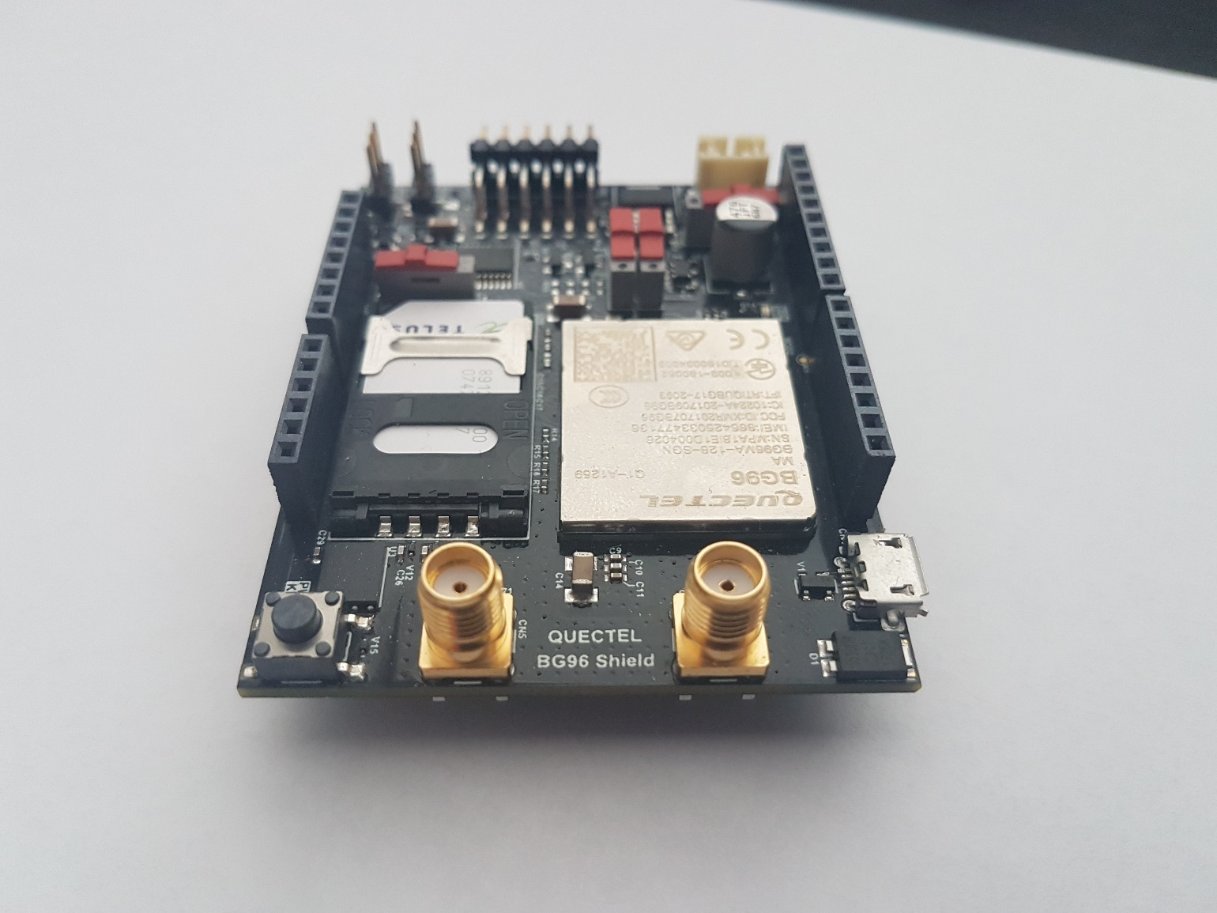

Remove

Replace with 90 deg connectors

Figure 17: BG96 board modifications

Ultimately, the optimized prototype did not fully materialize but this section describes the aspects that we worked on, our rational for different design decisions and the challenges that we faced.

#### 4.2.2.1 Internal Storage

Initially, our team did not put internal storage as a high priority item due to the thought that all information will be collected in the Azure database. However, due to difficulties in separating data from different devices from Azure, greater emphasis was put on internal storage/wired connection download to a database (as different device information is easy to separate).

An IC EEPROM chip was initially chosen as the storage method of choice due to it being able to be compactedly mounted to a PCB. However, SD cards were later chosen due to the larger storage space and libraries available to interface with them. Using the built in Mbed libraries, “SDBlockDevice” and “FATFileSystem”, would allow us to create a FAT file system on the SD card. This comes with a few advantages over using an EEPROM. Firstly, the file system handles the allocation of memory on the storage device. All we need to do is tell the file system to create a text file, and it will return a file pointer which we can stream our data to. This would not be the case with an EEPROM where we would have to keep track of all the memory addresses of our data. Secondly, since our data would be stored in plain text in a FAT file system, it would be easy for the user to plug the SD card into their PC to retrieve their data in the event that the device failed.

To transfer data off the device and into a database (likely an Excel spreadsheet) we began to develop a Python GUI application. This application would automatically detect when the EMF Monitor was connected to the computer via USB (Figure 18) and then display the file system along with a list of active employees (Figure 19). The development of this program began shortly before COVID-19 suspended our project so only a skeleton of the program was completed. Additionally, we initially received a defective SD card breakout board which delayed our progress.

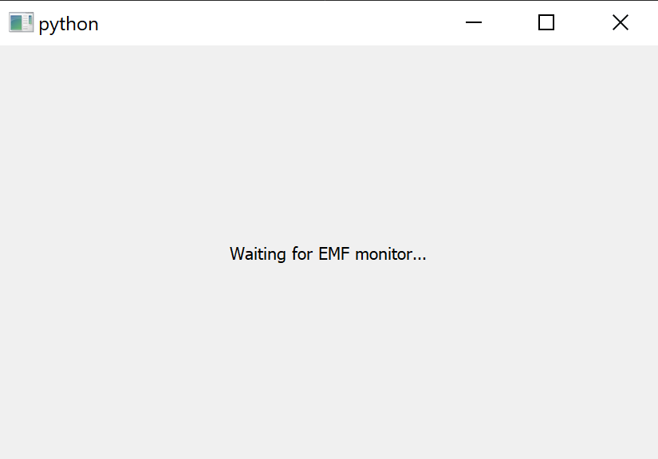

Figure 18: Python transfer app waiting

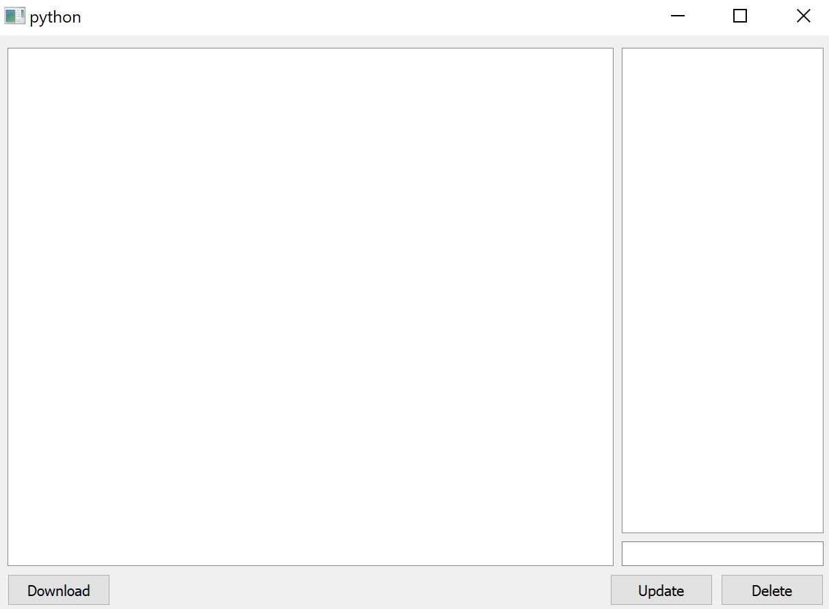

Add / Delete Users

* User 1
* User 2
* …

Download selected files

Select files

* Folder 1
  + File 1
  + File 2
  + …
* Folder 2
* Folder 3
* …

Figure 19: Python transfer app main window

#### 4.2.2.2 PCB Design

Our rationale for developing our own PCB was to keep our design as tight and succinct as possible, to allow design updates to be made easily down the line, and to minimize parasitic capacitances and inductances. Our goal was to replicate the functionality of the initial prototype on our custom PCB. The design was done with KiCad, parts were ordered off Digikey, and our PCB was ordered through ALLPCB.

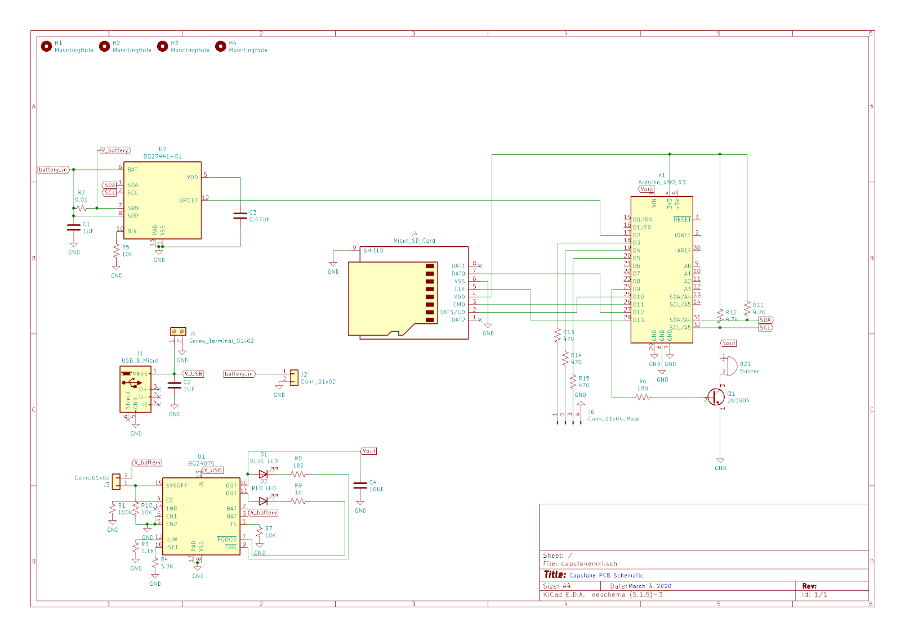

Figure 20: Schematic of custom PCB for optimized prototype

The left half of the schematic above showcases our charging circuit for the LiPo battery. It is inspired by the Battery Babysitter from SparkFun and utilizes the I2C-based BQ27441 IC, which gauges how much charge is left in the battery. Moreover, it can measure the output voltage, current, and power. These ICs are highly customizable as seen in their datasheets, however, to simplify design, these settings were either left on their default values or hardwired to their most stable option. The input to this charging circuit is a micro USB-B jack and a JST PH connector, which is the standard for LiPo batteries.

As mentioned in the previous section, we planned to have data recorded on to a micro SD card from the microcontroller. Thus, the PCB would have the micro SD jack sitting on the edge of the PCB top layer for ease of access. There are also connections to the GPIO of the microcontroller for an RGB status LED and a buzzer connected to a switching BJT. The reason the magnetometer is not included in the schematic is that we wanted to connect it to the GPIO away from the PCB in order to minimize electromagnetic interference from the PCB.

As mentioned earlier, our initial prototype was based on the NUCLEO-496ZG board. However, to cut down on the physical size, we switched to the NUCLEO-476ZG for the optimized prototype. This PCB can be thought of as a shield for the NUCLEO and the connections (Figure 21).

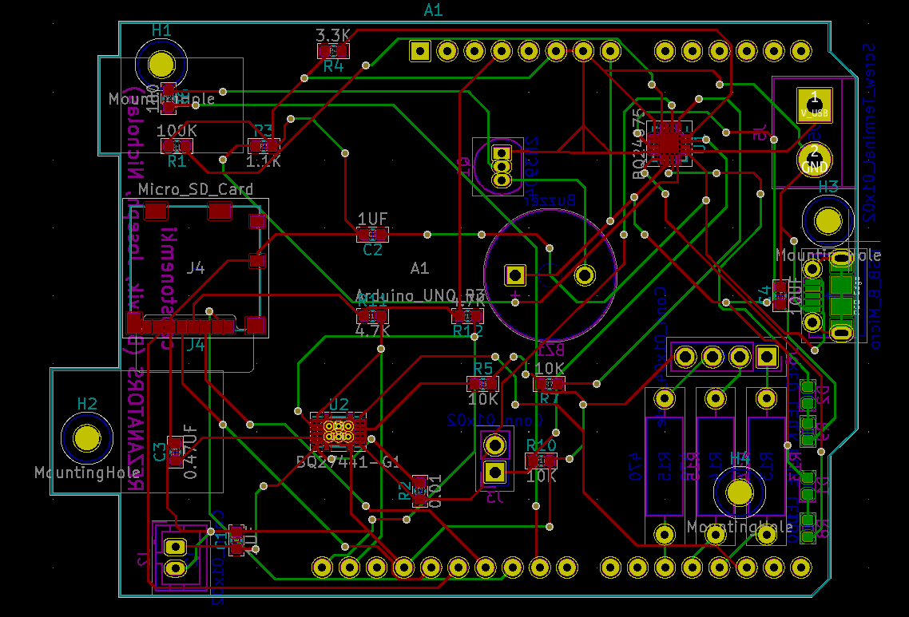

Figure 21: Copper traces for PCB design for optimized prototype

Although KiCad did not have a footprint or symbol for our board, the NUCELO-476ZG is Arduino Uno compatible so a footprint for it is shown on the schematic instead. The microcontroller pins would need M/F headers on the PCB similar to most Arduino Uno shields. The top layer is marked in red and the bottom layer in green. Parts were moved around until the layout seemed reasonable. A rendering of the PCB is shown in (Figure 22).

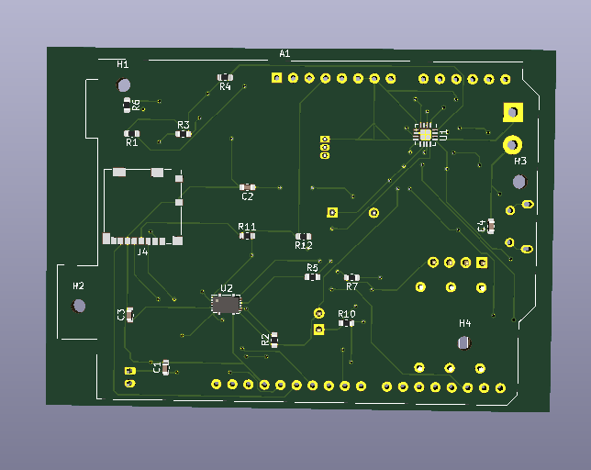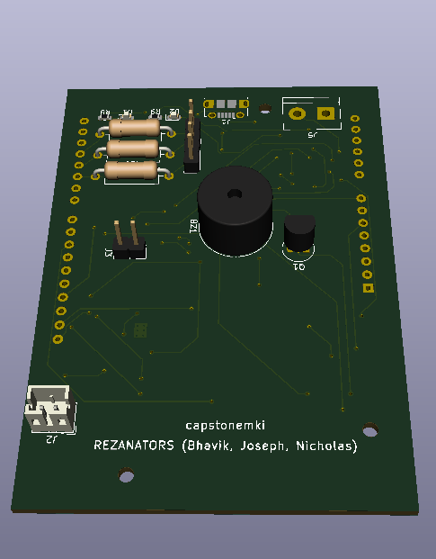

Figure 22: Render of PCB for optimized prototype

Once the layout was completed, Bhavik noticed one glaring issue in the 3D viewer. Everything on the top layer of the PCB would end up on the underside when it was actually placed on the NUCLEO meaning the overall layout was reversed. There was no easy way to invert the traces, so we switched layers on the bigger components and left most of the SMD components on the underside. Once the routing was done and inspected in the 3D viewer, we generated our Gerber and drill files and sent the order to ALLPCB. The production and delivery of the PCB was delayed due to COVID-19 and it reached BCIT after our capstone project was cancelled.

#### 4.2.2.3 Enclosure

The end enclosure for our optimized prototype was still undecided before capstone was prematurely ended. As per design requirement (7.1), the main enclosure requirements our team had to work around was that the casing would:

* Have in-built water resistance
* Be durable (ideally able to survive a 1 m drop)
* Be non-metal (e.g. plastic only)
* Fit in a pocket

The choice of enclosure came down to several models from Hammond Manufacturing, an electrical/electronic enclosure company. Our team was looking at models such as the 1591DBK, 1553CGY, RM2015M and others, which were plastic, had waterproofing built in, and were about the size we needed. Sizing was approximated by the width and length of the STM32L476 NUCLEO-64 board (7x8 cm). The height was approximated by stacking the NUCELO board, the LTE module, then adding ~2 cm for the battery, PCB, and screen/buttons. Adding some size safety margin was also considered when selecting prospective enclosures.

To test the suitability of the enclosures before we purchased one, our team downloaded the 3D schematic of the enclosures from the Hammond website, and converted it to a G-code file using SolidWorks in order to 3D print it. Unfortunately, our team started printing enclosures near the time of the capstone shutdown, and the attempts made prior to it failed due to the 3D printer misaligning during the printing process.

#### 4.2.2.4 User Interface

For the optimized prototype, the user interface was intended to be nearly the same as that of the initial prototype (functionality-wise is almost identical, though certain features may be tweaked or the code is cleaned up), though making such changes to the GUI did not happen prior to the end of capstone. What was done for the optimized prototype’s user interface is choosing the parts for the input and output.

The buttons for the input was tentatively chosen to be the PID #3024 waterproof push button from Lee’s Electronic Components because it:

* Has the required electrical behavior (normally open, momentary push button)
* Has a waterproofing gasket, thus ensuring water cannot leak through the hole drilled for the button
* Has a good tactile response (easy to feel when the button is pressed vs. not pressed)
* Has a lower profile compared to other panel-mounted styles of button

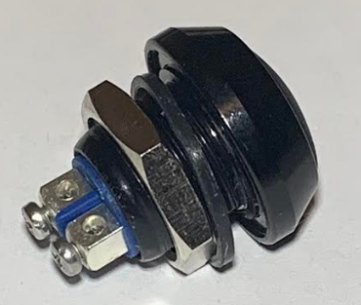

Figure 23: Button tentatively chosen for optimized prototype

This button was only tentatively chosen due to some uncertainty with the whether there was enough vertical space in the enclosure to accommodate the lower portion of the button with the other electronics. Moreover, as the choice of enclosure was not finalized yet, it was unclear if the button was look aesthetically pleasing when mounted on that enclosure.

The screen chosen for the optimized prototype is the 64128N FC BW-3LP from Mouser, which is a 124x64 pixel monochrome LCD screen.

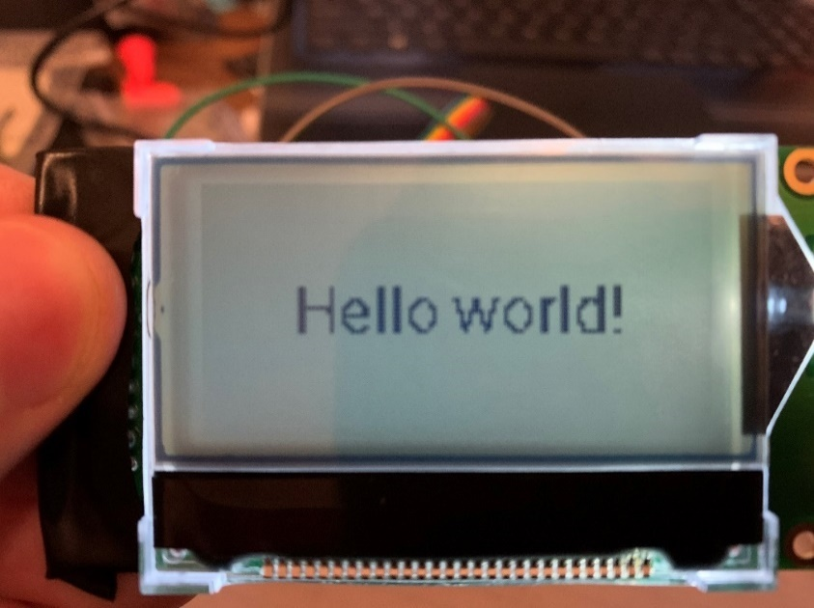

Figure 24: LCD screen when displaying text

The reasons for choosing this screen specifically are that:

* It aligns with design requirement (3.1) where the screen is large enough to fit all needed information and is easily viewable by the user (viewing area is 5x2.5 cm, allowing the user to read information easily but is not too large as to demand an unnecessarily large enclosure)
* RGB LED is undesirable due to color not being a design requirement, and because LCD consumes less power (saving battery life)
* This display has a backlight, allowing users to view information even in dim environments, and is needed to meet design requirement (7.2) where a backlight button is desired
* The price of the screen is not unreasonably high ($25.14 CAD at time of writing)
* The LCD driver IC (the ST7565) can accept information sent over SPI [22] (keeping the number of pins needed send information to the screen low compared to using parallel communication).
* The screen is mounted on a PCB with screw holes, making mounting the display to the enclosure easier

It was found that for the ST7565 of the screen to operate in SPI mode, an additional pin to the IC needs to be set to 0 V than when compared to parallel communication mode operation. Looking at the datasheets on the manufacturer’s website and verifying it with a multimeter, the J3 point (see Figure 25) on the PCB needed a solder bridge across it to accomplish this [22].

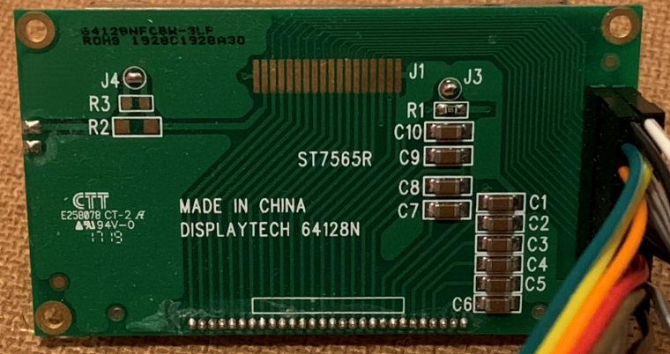

Figure 25: Solder bridge made across J3 (near top-right corner of the PCB) to enable SPI mode

However, for various reasons discussed in more depth at (4.3.1.3 User interface), our team was unable to get the screen properly working with its driver and therefore unable to use it to display the GUI.

### 4.2.3 Summary of Costs

Over the course of capstone, various parts were purchased to create or help in creating the initial and optimized prototypes. Most orders were done using the $1000 capstone budget allocated to our group. In total, we spent approximately $333 out of our budget. However, some components that were urgently needed and/or not too expensive were bought using the personal money from group members. Moreover, our mentor, Reza, helped us acquire an IoT Starter Kit from Telus, and a professional grade Gaussmeter. A full breakdown of items ordered for our capstone can be found in (Appendix B: Table of Orders).

## 4.3 Results, Testing, and Verification

This section describes the tests done to various modules of the EMF Monitor, and the results of those tests. Additionally, the tests also reference which design requirements they aim at verifying. For example, a reference to (1.1) indicates that the reader should refer to design requirement 1.1 “60 Hz EMF Sensing” from the design requirement spreadsheet [20]. Due to COVID-19 interrupting the execution of our project, these tests were only performed on our “Initial Prototype” (Figure 26). The PCB for our “Optimized Prototype” was still in shipping at the time so we were unable to verify that it worked. Some other design requirements that were also not verified are: (6.1), (6.2), (6.3), (7.1), (7.2), (7.3), (7.4) and (9).

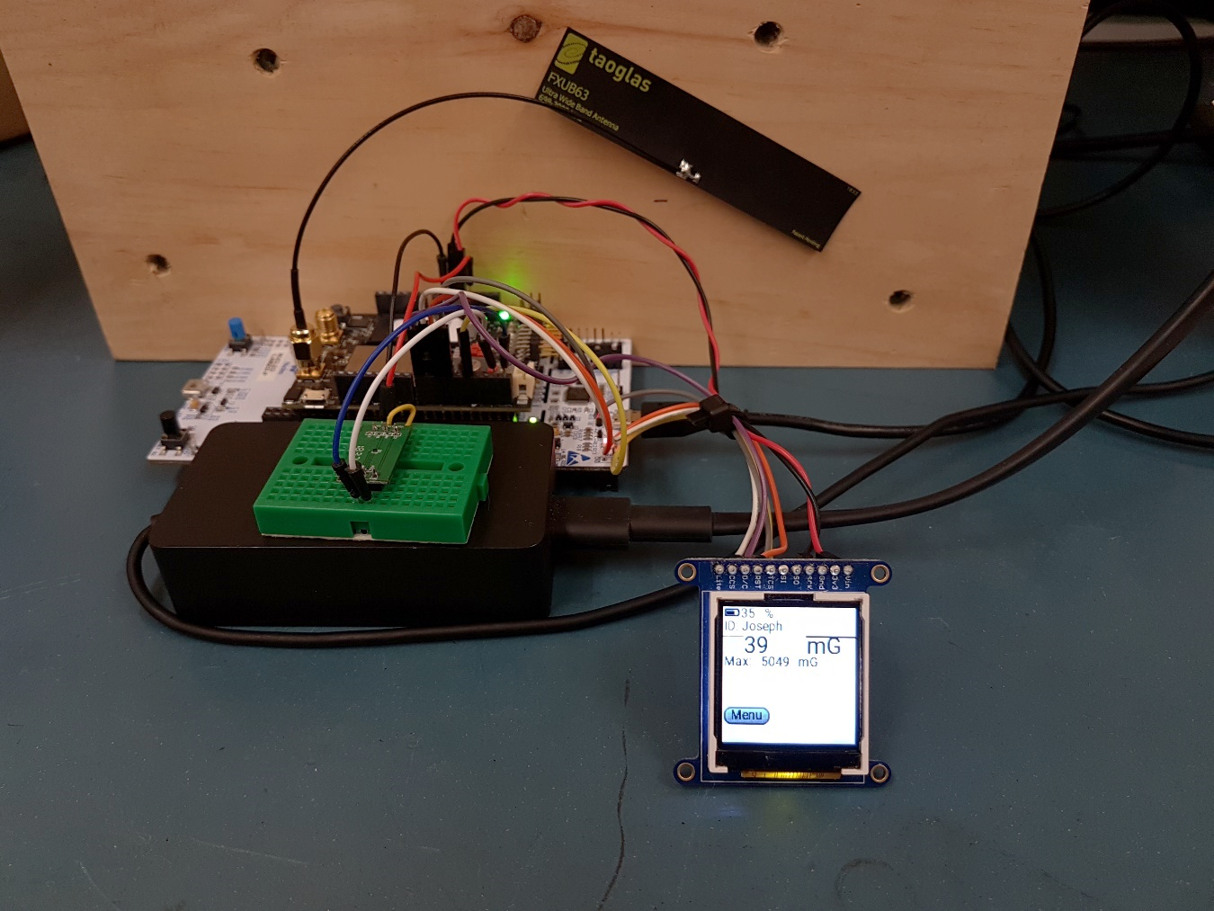

ST7735

LTE-M / NB-IoT Antenna

BG96 Modem Board

NUCLEO-L496ZG

MMC5603NJ

Figure 26: Initial prototype

### 4.3.1 EMF Measurement

There are three core design requirements relating to EMF measurement that require testing and verification:

1. 60 Hz EMF Sensing – The device can sense the 60 Hz EMF generated by power lines (1.1).
2. Data Processing – The device calculates magnetic and electric field exposure through isolation of the 60 Hz component (1.2).
3. Calibration – Through methods like temperature compensation and signal processing, the device’s EMF readings must be accurate to within +/- 5% of a commercial gaussmeter (1.3).

#### 4.3.1.1 60 Hz EMF Sensing

The first test that needed to be performed was determining if the LSM303AGR was capable of sensing 60 Hz EMF. As stated previously in (4.2.1.2 60 Hz EMF Measurement), the LSM303AGR could only achieve a maximum sample rate of 100Hz in continuous mode and 150 Hz in low power manual mode. We searched for a large source of EMF by using a cheap consumer grade gaussmeter (the AS1392) which is intended to measure 60 Hz fields. We found that placing the gaussmeter next to the power cable of a 1500 W space heater would produce readings between 200 and 300 mG. So, with a source found, we programmed our microcontroller to trigger the sensor manually at a rate of 140 Hz and logged the raw magnetic field strength values into a text file with the sensor next to the cable. We then performed an FFT on the data with MATLAB (Figure 27).

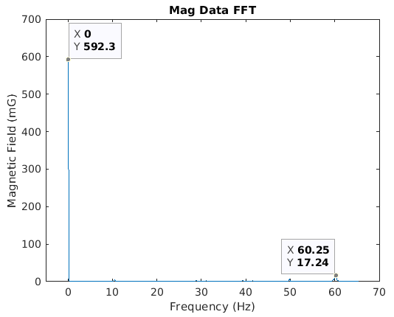

Figure 27: LSM303AGR FFT

When observing the spectrum, there is a large spike of 592 mG at 0 Hz which is associated with the Earth’s magnetic field. The rest of the spectrum is almost entirely blank, with a tiny bump of 17.2 mGaround 60 Hz. This was not the result we had hoped for, but we had already been looking for alternative sensors, so this was not a large setback for our project. As mentioned in (4.2.1.2 60 Hz EMF Measurement), we purchased the MMC5603NJ as a replacement.

After writing some code so the new sensor could communicate with our microcontroller, we setup the same test conditions as with the previous sensor. The MATLAB FFT of the data is shown below (Figure 28).

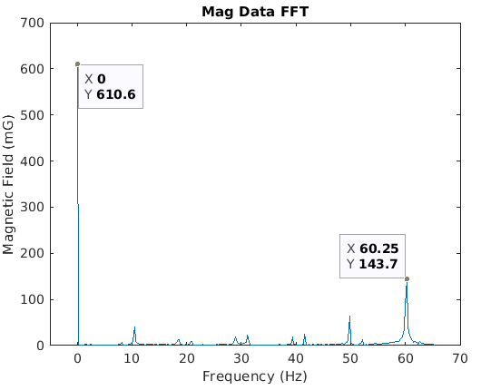

**?**

Figure 28: MMC5603NJ FFT

Again, we see a 600 mG spike at 0 Hz. However, this time the overall spectrum is more spread out. Most importantly, we see a 144 mG spike at 60 Hz which confirms that our new sensor can atleast sense 60 Hz EMF. This satisfies design requirement (1.1). One thing that we did not expect were the harmonics that ranged from 10 to 50 Hz. We would expect to see harmonics at integer multiples of 60 Hz (120, 240, etc) so one possibility was that aliasing was causing these higher frequency harmonics to appear at a lower frequency. According to the datasheet, the MMC5603NJ should be able to sample at up to 1 kHz which would allow us to measure frequencies up to 500 Hz without aliasing. We attempted to increase the sample rate of the sensor from 140 Hz to 1 kHz, but found that we could not increase it past 160 Hz without repeated data being produced by the sensor (Figure 29).

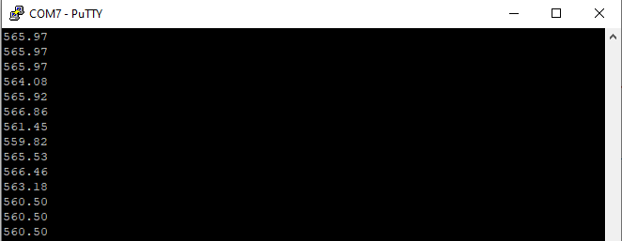

Figure 29: MMC5603NJ increased sample rate serial Output

We decided to move on for the time being, as we could always redesign our filter to include or exclude these harmonics if needed during calibration.

#### 4.3.1.2 Data processing

Our next step was to verify that the filtering mentioned in (4.2.1.2 60 Hz EMF Measurement) was producing the expected results. So, we used the same physical setup as in the previous test, enabled filtering, logged the output to a text file and imported it into MATLAB. An FFT was performed on the filtered data (Figure 30) and the filtered and unfiltered data was also plotted in the time domain side by side (Figure 31).

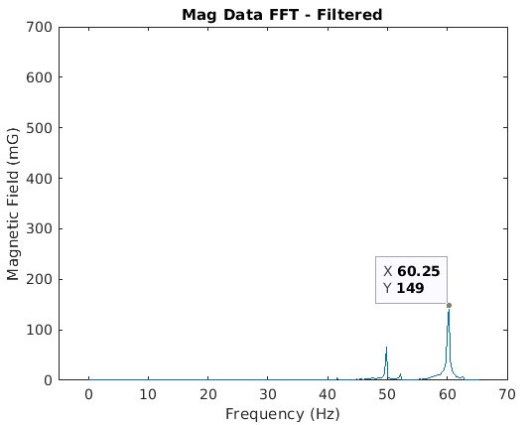

Figure 30: MMC5603NJ filtered FFT

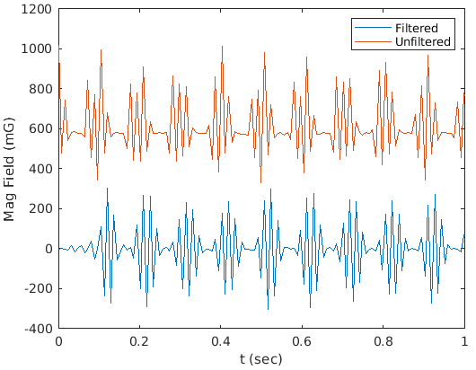

Figure 31: MMC5603NJ filtered and unfiltered EMF data

The resulting output in (Figure 23) is consistent with the designed frequency response of our filter (Figure 12). The large DC spike has been removed and the only significant EMF left is above the cut off frequency of 50 Hz. This satisfies design requirement (1.2).

#### 4.3.1.3 Calibration

Unfortunately, this design requirement was not completed due to the interruption of our project by COVID-19. While the project was still active, we ordered a Magnii DSP-523 Gaussmeter which can isolate 60 Hz EMF using digital signal processing. The plan was to use this meter as a benchmark for our device. If we could get readings that were within 5% of the DSP-523, then design requirement (1.3) would be satisfied. Some possible techniques for calibration would be temperature compensation, modifying the filter’s passband, and contacting MEMSIC for advice (the datasheet advises that you can “contact MEMSIC for access to advanced calibration and tilt-compensation algorithms”).

### 4.3.2 Battery

Reliable charging, discharging, and monitoring of the battery is crucial to the EMF Monitor. Testing was limited due to the surprise cancelation of capstone projects and the urgent need to develop the PCB. However, in development of the initial prototype, we tested:

1. Safely charging and discharging the battery and using the control switch to enable or disable battery output.

2. Powering the NUCLEO board off the Battery Babysitter.

3. Reading the remaining battery charge as a percentage via I2C communication.

#### 4.3.2.1 Charging and Discharging

The Battery Babysitter makes it simple to charge and discharge LiPo cells. It comes out of the box being able to do this except for the two output headers that need to be soldered on. The board also has a blue LED on it to display charging status and a red LED to show whether the board output is live. We noticed that if left charging overnight, the blue LED would turn off in the morning to show that the battery was topped up and not being overcharged. Due to time constraints however, all settings were left on default and no measurements were made on the charge/discharge currents and voltages.

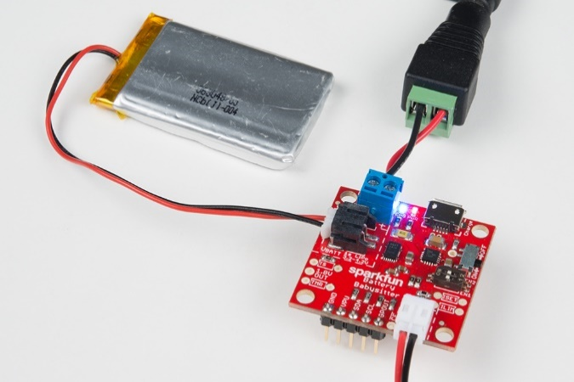

Figure 32: Blue LED indicating charge status and red LED indicating output status

#### 4.3.2.2 Powering the NUCLEO off the Battery Babysitter

The NUCLEO boards can be powered externally via their VIN pins. The Battery Babysitter output connects to the VIN and GND pins on the NUCLEO board. By default, the jumper for power input is over STLK for ST-LINK which refers to the main Micro USB connector. Power will only be drawn from VIN if the jumper has selected VIN as the input source. We saw that the NUCLEO can be powered off the LiPo but if left overnight, it will drain the battery as expected.

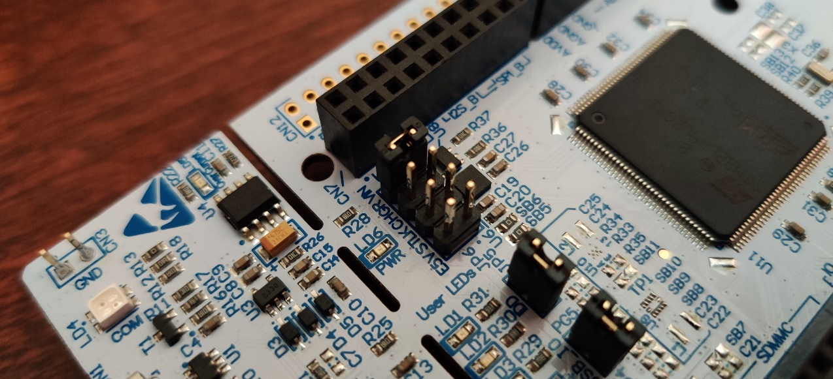

Figure 33: Headers for choosing input power source

#### 4.3.2.3 Monitoring the State of the Battery

Successfully communicating with the BQ27441 IC was the most difficult part of testing because Sparkfun only provided libraries for Arduino which were difficult to port over to our STM32 based microcontroller. Testing was done using the Mbed online compiler. This compiler did not have debug options so Bhavik did testing by printing over the COM port and viewing the result in Tera Term. The online compiler did have some basic sample programs such as and LED flasher and a sample of I2C code for the LM75. Bhavik tried tweaking the sample I2C code but the result obtainable with this method was a repeated error code appearing in Tera Term. When this method was not working, as well as after consulting Reza and his team members, Bhavik used an Mbed library specifically for the BQ27441 and was successfully able to read the battery percentage from the IC.

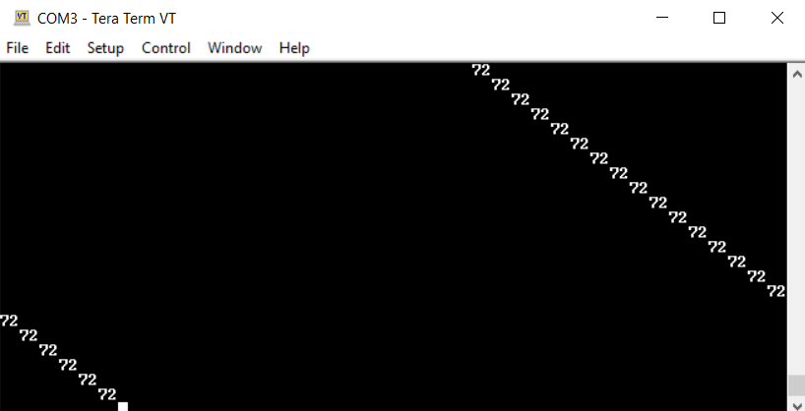

Figure 34: COM port showing battery percentage sent via I2C

### 4.3.3 User interface

After the completion of a major element of the EMF Monitor’s UI, testing is required to ensure that any subsequent software that relies upon that element functions correctly. The various tests during the UI development are:

1. Measure button input, with debouncing
2. Ensure screen for initial prototype works with microcontroller
3. Ensure LittleVGL can display dynamic values and respond to user input
4. Use LittleVGL to make menu system and display EMF information
5. Ensure screen for optimized prototype works with microcontroller

As mentioned in section (4.2.2.4 User Interface), the screen intended for use with the optimized prototype was unable to consistently work with the microcontroller, and therefore screens could not be swapped (i.e. step 5 was unsuccessful).

#### 4.3.3.1 Measure button input, with debouncing

For this project, several buttons are used as the user input to the EMF Monitor. In line with design requirement (3.4), all the input buttons need to be properly debounced since the number of button presses matter (e.g. for properly navigating menu lists). To test that an individual button press registers as one press by the microcontroller, a program was set up that counts the number of button presses there are, and sends that information serially to the computer where it can be viewed on a program such as PuTTY.

Interrupt service routines (ISRs) were configured to activate whenever the pin that the button is connected to has a voltage transition from 3.3 V to 0 V (pull-up resistors were used with the button to force the voltage level to 3.3 V whenever the button is not pressed). Once in the ISR, the program has a timer that counts for a certain time before checking the input of the button’s pin. The debounce time for the test was chosen to be 200 ms, with the expectation that the buttons used in the optimized prototype would have less bouncing (and therefore require a shorter debounce time).

The result was that the counter incremented only once for every button press. Quickly pressing a button, hitting multiple buttons, pressing/holding multiple buttons, and other combinations thereof yielded the expected outcome (no missed incrementations or double incrementations to the counters).

#### 4.3.3.2 Ensure screen for initial prototype works with microcontroller

The first step in developing the EMF Monitor’s output system is to ensure that the software driver used to interface the microcontroller with the screen works properly. A test program was set up to make the screen display shapes in different locations.

The first library attempted for this task was one used for a different school project that used the same screen. Since the microcontroller used was different than the one used in this capstone, certain tasks such as setting pinouts/configuring the SPI had to be adapted to work in the Mbed environment. Unfortunately, the library did not work out. The screen would power on (as 3.3 V and GND wires were connected to the screen) but it would not respond to any commands given to it. The problem was speculated to be an error in translating the functions from the previous microcontroller architecture to the current one (either something was not changed, or something was changed incorrectly). Some debugging was done including adding delays between commands (which was a problem in the other school project), rewriting the functions again, and checking the output signal on an oscilloscope. As the signal seemed to be correct, it was decided it may be faster to use a different library instead of putting more time into trying to fix the current one.

The new library, made by Roland Kamp, was intended to work with the Mbed OS [24]. With this library, the test program that printed shapes at different locations worked correctly. The program was re-loaded with the shapes set to different locations/colors to check that the screen updates properly. Unfortunately, the functions that were meant to print strings or characters did not work (perhaps due to using functions/dependencies not included in our Mbed setup) and were unable to be fixed, so new functions and bitmaps for each character were written to accomplish that task. (Figure 35) shows the screen displaying the test information. The reason for writing functions to write characters when LittleVGL would later be used do that, is so the screen is still usable as an output device if the GUI library does not work/ends up being unsuitable for whatever reason.

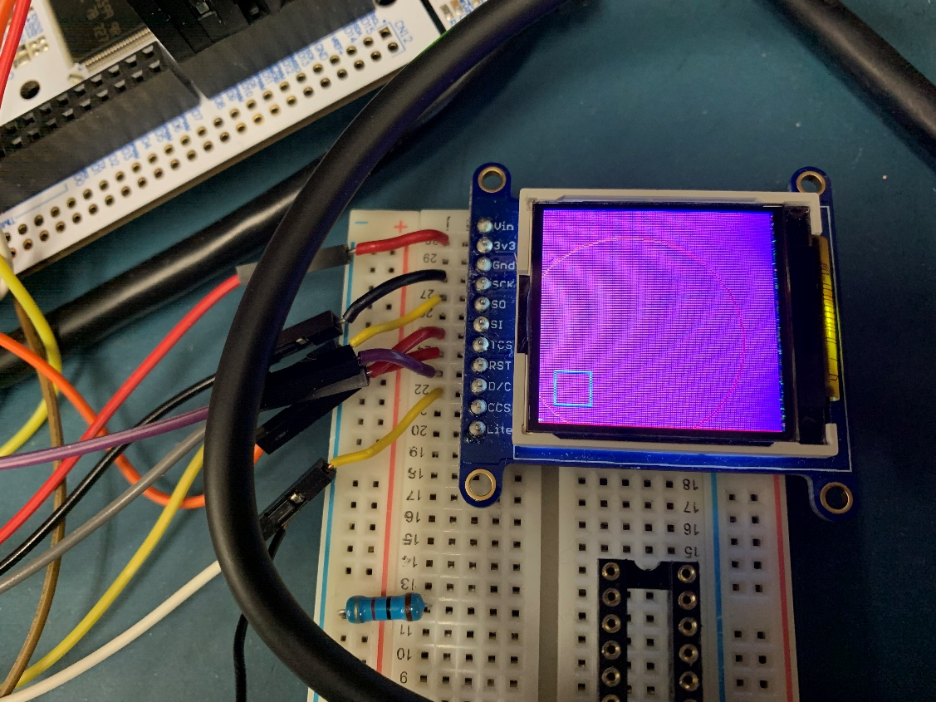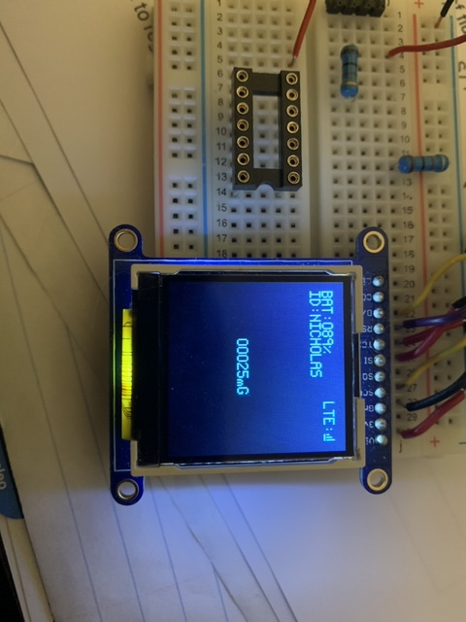

Figure 35: Testing to see if the screen driver works using shapes (left) and strings (right)

#### 4.3.3.3 Ensure LittleVGL can display dynamic values and respond to user input

The GUI was developed with the intent of meeting design requirement (3), where various pieces of EMF information is displayed, and (3.3), where a menu can configure different settings of the device. Although there were some difficulties when trying to get LittleVGL to work in the Mbed environment (in ensuring all the dependencies are included and the required variables/setup procedures were done), they were eventually solved. However, this delayed progress on the GUI as an incorrectly usage the library may cause the program to crash. Since we did not have a debugger, isolating where a crash occurred took additional time.

To set up the foundation for meeting the aforementioned design requirements, a test of user interaction was set up where a button would be used to increment a variable (initially set to a value of 1,095), the value of which is displayed on the screen. Although a user input was able to change a value and have that reflected on the screen through the GUI system, one immediate concern that arose was the screen update time. (Figure 36) shows how the transition from 1,099 to 1,100 on the screen is slow enough to capture on camera.

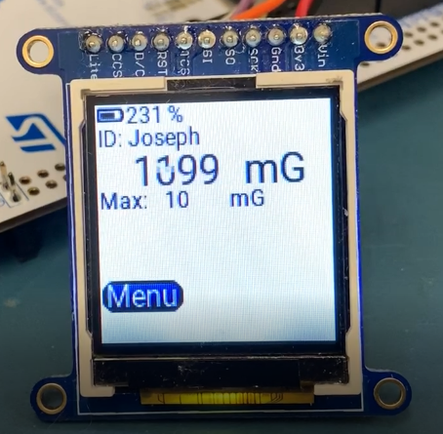

Figure 36: Screen linking input and output through GUI library.

For single or double-digit number, the update time is almost unnoticeable. However, updating a five-digit number, the largest digit number our EMF Monitor is meant to display, takes approximately one second to complete (some variation is present, depending on the font of text used). The reason for this was found in how LittleVGL sends information to the screen. By default, LittleVGL creates a bitmap of the area to update, then tells the screen driver to send the update pixel-by-pixel. For every pixel sent, the screen driver software has to tell the screen it is sending a command to change the value of a memory location, what the memory location is, and what value to set the color to. This totals to 11 bytes of setup sent for every 2 bytes of pixel color.

The solution was to modify each update to use a rectangle area update. The command information specifying the area to update only needs to be sent once, then all the color pixel data can be sent in a stream. (Table 5) shows the difference between using the prior operation compared to the new one when updating 1,024 pixels (1/16 of the area of a 128x128 pixel screen).

|  |  |  |  |
| --- | --- | --- | --- |
| Screen update method | Non-color bytes sent | Color bytes sent | Total bytes sent |
| Pixel-by-pixel update | 11,264 | 2,048 | 13,312 |
| Rectangle update | 11 | 2,048 | 2,059 |

Table 5: Comparison of bytes send using pixel-by-pixel updates vs. rectangle area updates

With the new system, the number of bytes sent to the screen was drastically reduced and therefore increased update speeds. Although smaller areas do not benefit as much from this new system (e.g. the number of bytes sent for one-pixel changes is the same for both systems), it was the larger update areas that needed and benefitted the most from this change. Overall, this made displaying dynamic, five-digit numbers almost unnoticeable.

#### 4.3.3.4 Use LittleVGL to make menu system and display EMF information

After creating the main page and two settings pages of the menu system, the following aspects of the menu were tested to satisfy design requirement (3.3):

* **Page navigation**: See that all the buttons that go to other menu pages are linked correctly.
* **Wrap-around**: Ensure that when trying to scroll past the last menu item selects the first item (and vice versa).
* **Changing setting flags**: When the “enter” button is hit, the selected setting flag toggles.
* **Setting change permanence**: After changing settings, make sure that the settings “remember” what state they are in after changing pages.

Testing for each aspect was done in the order they are listed above (e.g. all the menu navigation buttons were tested to see if they go to the correct menus before the wrap-around aspect of the menu lists were tested). Some bugs were detected while verifying the menu’s functionality (e.g. menu selection wrap-around when scrolling past the last menu item not working correctly), they were corrected. The setting flags for the “change units”, “change field”, and “factory reset” features are incomplete, due to the new screen ordered for the optimized prototype arriving and effort being put into trying to get that to work (due to that being a higher priority task to complete).

#### 4.3.3.5 Ensure screen for optimized prototype works with microcontroller

Like with the ST7735 screen before it, the 124x64 pixel monochrome LCD screen used in the optimized prototype needed a screen driver library for the microcontroller to interface with it. This screen had the ST7565 chip, a library for which was included in the list of included drivers for LittleVGL. Unfortunately, there was limited success using the library, as it seemed to work intermittently; sometimes the screen would display the “Hello world!” text sent to it, but if the program was re-loaded, it may display nothing instead. The debugging process included swapping out all the wires connecting the microcontroller with the screen (in case there was a poor connection with one of the wires), adding delays to the program, re-writing the library functions, and checking online sources (such as Stack Overflow) for similar issues. Trying the library made by Adafruit [25] for the ST7565 also failed. Due to the COVID-19 situation, capstone was cut short before a solution to this issue was found.

# 5 Conclusions and Recommendations for Future Work

We set out to create a unique device which combines signal processing and IoT technology to provide BC Hydro employees with peace of mind while working in the presence of electromagnetic fields. We faced many challenges along the way. The lack of documentation for many modules of our project combined with having no access to a debugger made progress slow. This is evident from our GANTT chart [26], which indicates that we fell behind on a few aspects of the project. However, the results from (4.3.1.1 60 Hz EMF Sensing) are promising and show that isolating 60 Hz EMF with the cost effective MMC5603NJ sensor is possible using signal processing. As for the IoT aspect of our project, we would recommend careful consideration before continuing development. We envisioned that Azure IoT Central would simplify many parts of our design, taking away the need to develop our own database or data transfer application. Instead, it complicated development and added unneeded costs (as described in 4.2.1.3 Azure IoT Central). If you still like the idea of wireless data transfer, we suggest looking into integrating Bluetooth or some other short-range wireless technology into this device.

Overall, due to the many challenges we faced and COVID-19 shutting down the capstone at a critical junction in the project (where integration of the modules and finalization of the remainder of features/parts selection was taking place), there are a lot of outstanding development items. However, the features that were completed include 60 Hz EMF isolation, a GUI menu system, a module to safely charge the battery, and a custom PCB for the optimized prototype. The key work that remains to be done is calibration of the magnetometer, integration of the UI with its connected modules (e.g. connect the battery charge state value to its label in the UI), development of a cloud-based database solution and/or development of a physical storage solution (SD card with data transfer application), soldering and testing of the PCB, final assembly of the device into an enclosure, and testing of the device in the field.

Once all the aforementioned features have been completed, one interesting possibility for future work would be making use of the GPS module on the BG96 modem board. GPS coordinates paired with magnetic field data could be used to create a map of magnetic field strength in an area. This could have both commercial and consumer applications. For example, BC Hydro could create a map of their facilities so that the areas that are safe to work in are clearly defined. On the consumer side, imagine that you are interested in purchasing a house located near high voltage powerlines. You could have complete knowledge of the magnetic field strengths in all areas of the property if you took this device with you on a tour. Implementing this functionality in our device would be fairly trivial, as there are built in functions to control the GPS module of the BG96 in Mbed. For visualization of the data, Azure IoT Central supports plotting location data on a map, but we recommend finding something a bit more robust as we had issues with its barebones nature over the course of our project.

References

|  |  |
| --- | --- |
| [1] | N. Huttemann, B. Maisuria and J. Dobrzanski, "ELEX7790 - Capstone - Full Proposal," BCIT, Burnaby, 2019. |
| [2] | World Heath Organization, "What are electromagnetic fields?," 2016. [Online]. Available: https://www.who.int/peh-emf/about/WhatisEMF/en/index1.html. [Accessed 7 October 2019]. |
| [3] | B. Stewart, *MMBU MFC Project,* BC Hydro, 2019. |
| [4] | E. Al-Dabbagh, J.-H. Storm and R. Körber, "Ultra-sensitive SQUID Systems for Pulsed Fields--Degaussing Superconducting Pick-Up Coils.," June 2018. [Online]. Available: http://web.b.ebscohost.com/ehost/detail/detail?vid=5&sid=46118ad7-f94a-4706-a0ab-32e29782c605%40sessionmgr101&bdata=JkF1dGhUeXBlPWlwLHNzbw%3d%3d#AN=128707682&db=bth. [Accessed 14 October 2019]. |
| [5] | M. Blagojević, U. Jovanović, I. Jovanović and D. Mančić, "Folded bus bar current transducer based on Hall effect sensor.," June 2018. [Online]. Available: http://web.a.ebscohost.com/ehost/detail/detail?vid=4&sid=2c49e653-0c2e-4eef-b100-f948cbec748e%40sdc-v-sessmgr03&bdata=JkF1dGhUeXBlPWlwLHNzbw%3d%3d#AN=129652720&db=a9h. [Accessed 14 October 2019]. |
| [6] | Magnii Technologies, "DSP-523 Gaussmeter," [Online]. Available: https://magnii.com/product/dsp-523/. [Accessed 2 October 2019]. |
| [7] | "Gaussmeter Model GM2," ALPHA INC., [Online]. Available: https://www.alphalabinc.com/product/gm2/. [Accessed 14 October 2019]. |
| [8] | "Magnetometer-BLE," Iot-SHOPS.com, [Online]. Available: https://www.iot-shops.com/product/magnetometer-ble/. [Accessed 10 October 2019]. |
| [9] | "Bitalino R-IoT Kit Full-Featured 9DOF Wireless IMU in a Stand-Sized Package with Direct OSC Streaming over WiFi," Bitalino, [Online]. Available: https://bitalino.com/en/r-iot-kit. [Accessed 28 October 2019]. |
| [10] | Speedify Desktop, "What is the difference between Wi-Fi and Cellular connections?," Speedify, 5 November 2018. [Online]. Available: https://support.speedify.com/article/257-what-is-the-difference-between-wifi-and-cellular-connections-how-to-avoid-internet-connection-interruptions. [Accessed 29 October 2019]. |
| [11] | D. Evans, "The Internet of Things - How the Next Evolution of the Internet is Changing Everything," April. [Online]. Available: https://www.cisco.com/c/dam/en_us/about/ac79/docs/innov/IoT_IBSG_0411FINAL.pdf. [Accessed 28 10 2019]. |
| [12] | 3GPP, "Release 13 - High level overview of features," 9 10 2015. [Online]. Available: https://www.3gpp.org/ftp/Information/WORK_PLAN/Description_Releases/Rel-13_description_20150917.zip. [Accessed 09 10 2019]. |
| [13] | Telus, "Telus Coverage Map," [Online]. Available: https://www.telus.com/en/bc/mobility/network/coverage-map?INTCMP=VAN_coverage. [Accessed 9 10 2019]. |
| [14] | B. O. Anyaka and U. B. Akuru, "Electromagnetic Wave Effect on Human Health: Challenges for Developing," in *IEEE*, Sanya, 2012. |
| [15] | ICNIRP, "ICNIRP Guidelines for Limiting Exposure to Time-Varying Electric and Magnetic FIelds (1 Hz - 100k Hz)," *Health Physics,* vol. 99, no. 6, pp. 818-836, 2010. |
| [16] | IEEE, "C95.1-2019 - IEEE Standard for Safety Levels with Respect to Human Exposure to Electric, Magnetic, and Electromagnetic Fields, 0 Hz to 300 GHz," IEEE, 2019. |
| [17] | V. Feichtinger, F. Alber and S. Neugschwandtner, "BUSA510 Final Report," BCIT, Burnaby, 2019. |
| [18] | ST Microelectronics, "LSM303AGR Datasheet," November 2018. [Online]. Available: https://www.st.com/resource/en/datasheet/lsm303agr.pdf. [Accessed 05 December 2019]. |
| [19] | MEMSIC, "MMC5603NJ Datasheet," 7 12 2018. [Online]. Available: https://www.mouser.com/datasheet/2/821/Memsic_09102019_MMC5603NJ_Datasheet_Rev.B-1635324.pdf. [Accessed 28 April 2020]. |
| [20] | N. Huttemann, B. Maisuria and J. Dobrzanski, "EMF Monitor Design Requirements.xlsx". |
| [21] | ST Microelectronics, "STM32L496xx Datasheet," January 2020. [Online]. Available: https://www.st.com/resource/en/datasheet/stm32l496zg.pdf. [Accessed 29 April 2020]. |
| [22] | Displaytech, "64128N Graphic LCD Module," [Online]. Available: https://www.displaytech-us.com/128x64-graphic-lcd-displays-n. [Accessed 12 January 2020]. |
| [23] | Quactel Wireless Solutions, "BG96 Datasheet," 2020. [Online]. Available: https://www.quectel.com/UploadFile/Product/Quectel_BG96_LPWA_Specification_V1.8.pdf. [Accessed 29 April 2020]. |
| [24] | R. Kamp, "ST7735," 22 August 2015. [Online]. Available: https://os.mbed.com/users/rolo644u/code/ST7735/file/291ac9fb4d64/ST7735.cpp. [Accessed 4 January 2020]. |
| [25] | Adafruit, "ST7565-LCD," 6 October 2015. [Online]. Available: https://github.com/adafruit/ST7565-LCD. [Accessed 3 March 2020]. |
| [26] | N. Huttemann, B. Maisuria and J. Dobrzanski, "ELEX7790_Work_Plan_GANTT_Chart.mpp". |

# Appendix A: Magnetometer Sensor Thread Flowchart

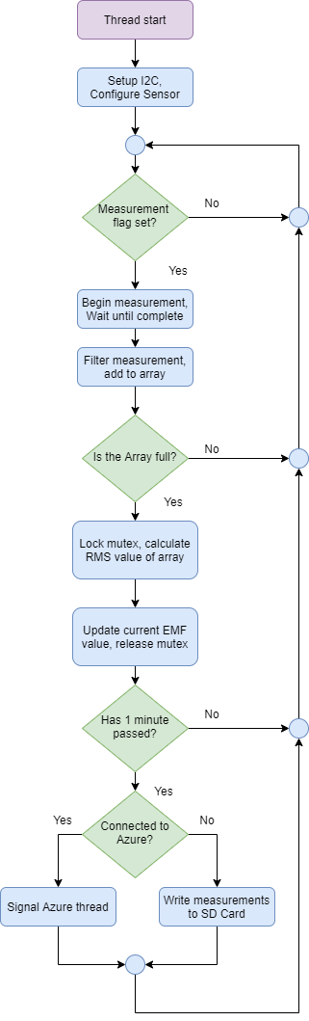

Figure 37: Magnetometer sensor thread flowchart

# Appendix B: Table of Orders

|  |  |  |  |
| --- | --- | --- | --- |
| Date | What was ordered | Why it was ordered | Cost |
|
|
| 10-Oct-19 | Telus IoT Development Kit (AES-BG96-IOT-SK2-G) | main microcontroller with LTE and sensor shields | $184.33 |
| 08-Nov-19 | SparkFun Battery Babysitter, two more NUCLEO496 boards, and LiPo cell | needed charging circuit to safely charge and monitor LiPo cell | $100.09 |
| 28-Nov-19 | Display TFT 1.44 color with microSD slot | simple LED display to develop UI for EMF monitor | $22.78 |
| 21-Jan-19 | Magnetic sensor breakout board and PolarTools EMF Detector B07G36W4B6 | upgrade to default magnetometer from IOT Starter Kit in terms of resolution and | $61.37 |
| 07-Feb-20 | DSP-523 magnetometer | to have a robust measurement for EMF as reference | $309.00 |
| 12-Feb-20 | NUCLEO-L476, EEPROM, SMA PCB JACK, LCD | parts needed for optimized prototype | $60.72 |
| 24-Feb-20 | BOB-00544 Micro SD breakout | test data storage on Micro SD instead of EEPROM IC | $6.86 |
| 03-Mar-20 | PCB | basis for the optimized prototype containing connections for the charging circuit, warning LEDS and buzzer, micro SD jack | $33.50 |
| 04-Mar-20 | PCB components | parts needed for the optimized prototype containing charging circuit, warning LEDS and buzzer, micro SD jack | $54.55 |
| 07-Mar-20 | Waterproof pushbutton | testing feasibility with enclosure | $4.50 |
| 10-Mar-20 | SMD Soldering Gear | for soldering SMD components onto custom PCB | $22.81 |

Table 6: Table of capstone expenditures

For the above table, the different colors are:

* **Orange**: Item was bought out of pocket by the team
* **Blue**: Item was bought using capstone project budget
* **Grey**: Item Reza helped us acquire for our capstone